**Question one:**

Small lumps of marble chips were added to dilute hydrochloric acid in the apparatus shown in the diagram.

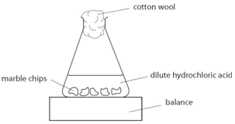The balance reading was noted as soon as the lumps were added, and again every 20 seconds. The experiment was repeated by using different sizes of the marble chips.

1. **Write the word equation for this reaction.**

**Marble chips, calcium carbonate react with hydrochloric acid to produce carbon dioxide gas. Calcium chloride solution is also formed.**

1. **Suggest why a cotton wool was placed in the mouth of the conical flask.**

**The purpose of the cotton wool is to allow carbon dioxide to escape, but to stop any acid from spraying out.**

**The results of the investigation were plotted on the graph as shown.**

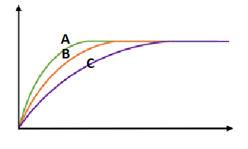 y-axis

**Mass loss(g)**

**Time(seconds) x-axis**

1. **Label the X axis and the Y-axis**
2. **Label the marble chips with the smallest surface area.**

**C**

1. **Decide if the following statements are true or false:**
2. **Line A represents the results of the large chunks reaction. false**
3. **All the three experiments ended at the same time and caused the same mass loss. false**
4. **The reactions are the fastest at the beginning. true**
5. **The three lines turned flat because the students stopped collecting data. false**

**Question two:**

**Two 10g samples of marble of different sizes, A and B, were each reacted with 50 cm3 of diluted hydrochloric acid. The mass of carbon dioxide formed in each reaction was recorded and plotted to produce the graph below.**

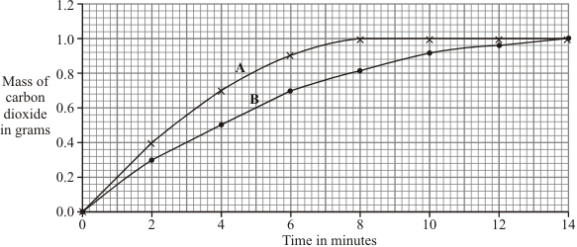

1. **Identify:**

* The dependent variable mass of carbon dioxide in grams
* The independent variable sizes of marbles (surface area)

1. **Fil in the table below with the missing results.**

|  |  |  |
| --- | --- | --- |
| **Time/ min** | **Sample** | **Mass of gas produced/g** |
| **4** | **B** | **0.5** |
| **8** | **B** | **0.8** |
| **14** | **B** | **1.0** |
| **2** | **A** | **0.4** |

1. **How long did it take sample A to finish the reaction?** 8 minutes
2. **Explain the results of the investigation, in terms of particles and collisions.**

The higher the surface area the more the calcium carbonate particles will collide with the hydrochloric acid so a faster reaction will take place in (A)

**Question three:**

**Some students were investigating how fast hydrogen gas is released in the reaction between magnesium and hydrochloric acid.**

**They used 0.1 g of magnesium ribbon with specific volume of diluted acid.**

**Next, they repeated the experiment using magnesium ribbon with the same volume of concentrated acid.**

**Their results are shown on the graph.**

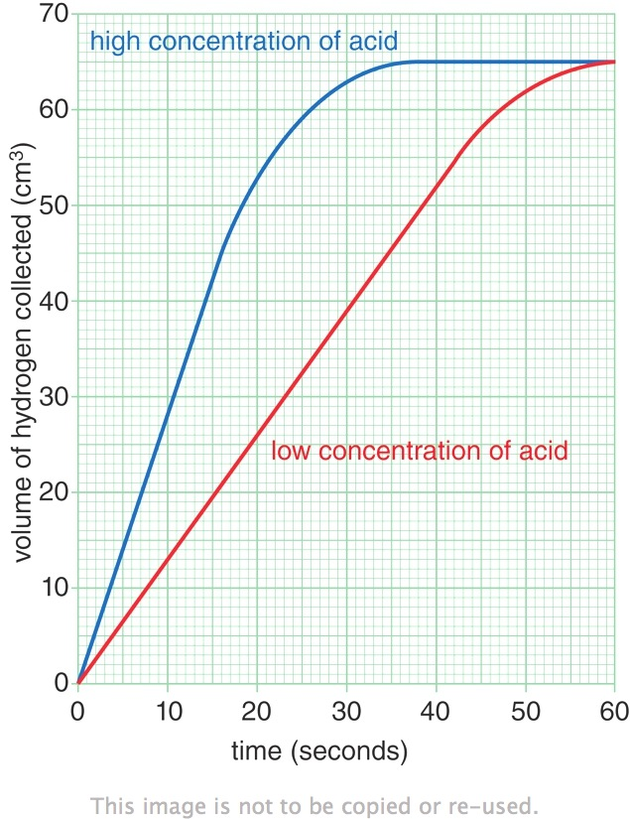

1. **How do you explain that the same volume of gas was given out in both experiments?**

Because same amounts of magnesium was used in both experiments

1. **The faster reaction was caused by using a concentrated acid. Explain, in terms of particles and collisions, why a higher concentration acid causes a faster rate of reaction.**

The higher the concentration of the acid the more the particles will collide with each other the more the collisions and the faster he rate of reaction.

1. **Why do you think the reaction with the diluted acid got slower between 45-55 sec?**

Because the concentration of the acid is lower with time (got used in the relation)