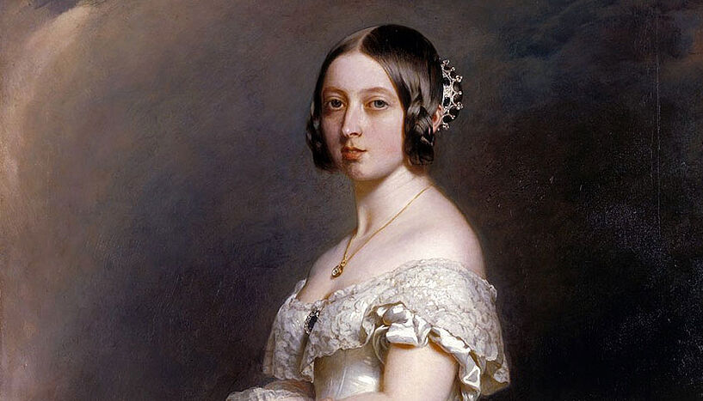

Victoria, queen of the United Kingdom

Victoria’s early life

Princess Alexandrina, Victoria was born into the British royal family on 24thMay, 1819. Her mother was extremely protective and the princess grew up under strict rules. She was never allowed to be alone. Her mother, her tutor or her governess was always with her. She shared a bedroom with her mother. In her playtime, her only friends were her dolls and her little dog, Dash. When she was older, she described her childhood as rather sad and lonely. At the age of seventeen she was introduced to a handsome young German, Prince Albert. She liked him at once but she was not yet ready to marry.

A new queen

The princess was 18 on 24th May, 1837. Less than a month later, her uncle, the king, died and she became queen on 20th June, 1837. Her first requests were to have an hour by herself and to have her bed removed from her mother’s room to a bedroom of her own. She did not want to be called Queen Alexandrina. Instead she asked for her second name, Victoria, to be used.

Marriage

Victoria was crowned on 28th June, 1838, an she made

Buckingham Palace her home. Because she was not married, her mother also lived in the palace but Victoria often refused to see her. She met Prince Albert several times over the net two years. Finally, she asked him to marry her and their wedding took place on 10th February, 1840. Victoria adored her new husband from the start and she relied on him for advice and support in her role as queen. She had to meet the prime minister, listen to his ideas for government and make decisions about matters of state.

Family life

Their first child was born in November, 1840, and over the next seventeen years they had eight more children. Family life became important to Victoria. With Prince Alberts guidance she became a better daughter to her mother. When her mother died in march, 1861, Victoria was at her bedside. In December of the same year, Prince Albert died after a short illness and Victoria was devastated. She wore black for the rest of her life. She continued her government duties but she did not live un London. She stayed In her castles in the south of England and in Scotland. Because of this, she was not so popular as before. She was advised to be seen in public more often and gradually she appeared at more public events.

The British Empire

During Victoria’s reign the British Empire expanded. Much of India came under British rule from 1st may, 1876, Victoria was also named Empress of India. In her opinion, the expansion of the British Empire helped other countries and protected people from cruel rulers. Other countries did not have the same point of view and saw Britain as a threat. Britain was often at war for the Empire, which was more powerful than it had ever been before.

The Victorian period

Victoria’s reign was known as the Victorian period. Family life was important to everyone. Bad behaviour was not allowed and children had to be obedient. It was a time of industrial progress. Factories, railways, and bridges were built. Cities expanded greatly. For those who had jobs and comfortable homes, life was pleasant, but for the poorer people who lived in the worst houses, life was hard. Work in the factories was exhausting and often dangerous. Many people spoke out against the harsh conditions and the well-known writer, Charles Dickens, wrote about them.

Final years

Victoria’s reign of 63 years, 7months and 2 days was longer than the reign of any king or queen before her. She had became immensely popular. Her children had married into European families and she had more than thirty grandchildren. She was known as (the grandmother of Europe). When she became ill and died on 22nd January, 1901, aged 81, the whole population was deeply saddened. She was buried next to her husband, Prince Albert.