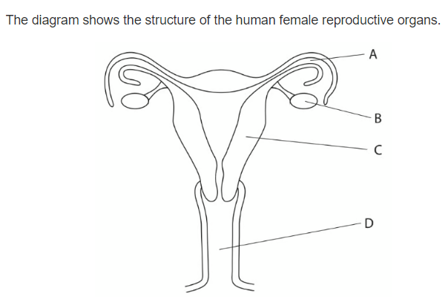**Question 1 :**

x

* Which letter represent the site of fertilization ………A………….
* Which letter shows were the fetus usually develop ………C…………….
* Name organs :

B : ………ovaries……………………

A : ………oviduct/fallopian tube…………………….

C : ………uterus…………………….

* Draw an x on the diagram to show where implantation takes place .
* State what is meant by the term menstruation .

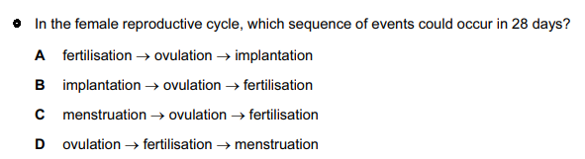………cycle where the uterus walls collapse and the unfertilized egg leave the body …………………………………………………………………………………….



**Question 2 :**

1. Khalil is one of three boys , his parents are expecting another child and they are certain it will be a girl . Explain why they are wrong ? *( 1 marks )*

……they cant be sure whether it’s a boy or a girl because it is a 50 50 chance ………………………………………………………………………………………………………………

………………………………………………………………………………………………………………………

1. Copy and complete the diagram to show how the sex of the baby is inherited.

*( 4 marks )*

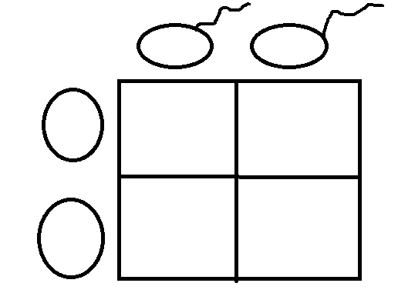

X

Y

XX

XY

X

XY

XX

X

**Question 3 :**

Arrange these objects in size order, starting with the largest. *( 2 marks )*

Nucleus chromosomes gene cell DNA

…cell-🡪 nucleus-🡪 chromosomes 🡪 DNA -🡪 gene ……………………………………………………………………………………………………………………..

**Question 4 :**

The diagram shows an egg, a sperm and a fertilized egg. *( 3 marks )*

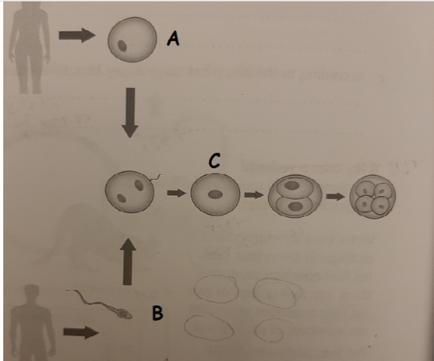Label the diagram to show how genes from each parent get into all an embryo’s cells

**Question 5 :**

Demonstrate how an egg cell is adapted to its function .

……jelly layer protects the cell and attracts the sperm, cytoplasm with fat stored……………………………………………………………………………….

…………………………………………………………………………………….

……………………………………………………………………………………