**Question one:**

**Marble chips react with dilute hydrochloric acid.**

**CaCO3        +         HCl       →        CaCl2        +        H2O       +        CO2**

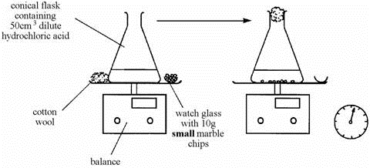**A student wanted to find out if the size of the marble chips made a difference to how fast the reaction took place. She used powdered marble chips as shown below:**

1. What is the name of these compounds:

**CaCO3 calcium carbonate CaCl2 calcium chloride**

1. What readings should she take during the test?
2. Measure the initial time 2. The time when the experiment is finished

**She repeated the experiment but this time used large marble chips.**

1. What variables must be controlled to make it a fair test? **The same concentration of HCL, the same mass of marble chips**

**These are the results of the two experiments.**

|  |  |  |  |  |  |  |  |
| --- | --- | --- | --- | --- | --- | --- | --- |
| **TIME (seconds)** | 0 | 20 | 40 | 60 | 80 | 100 | 120 |
| **Mass loss (g), using small chips** | 0.00 | 0.40 | 0.72 | 0.91 | 1.04 | 1.04 | 1.04 |
| **Mass loss (g), using large chips** | 0.00 | 0.28 | 0.52 | 0.70 | 0.84 | 0.94 | 1.04 |

**d)**Explain the reason of the mass loss in the two experiments**. by increasing the surface area more particles are exposed to the reactant, more carbon dioxide gas is produced, and the carbon dioxide gas escapes the solution**

**e)** Complete the table below

|  |  |  |
| --- | --- | --- |
|  | **Using small chips** | **Using large chips** |
| **Time taken for the reaction to be done (sec)** | **80s** | **120s** |
| **mass loss (g)** | **1.04g** | **1.04g** |

**Question two:**

**Two 10g samples of marble of different sizes, A and B, were each reacted with 50 cm3 of diluted hydrochloric acid. The mass of carbon dioxide formed in each reaction was recorded and plotted to produce the graph below.**

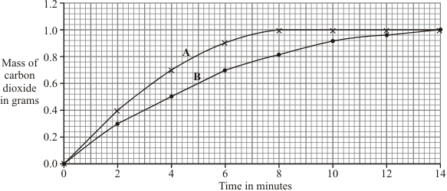

1. Fill in the table below:

|  |  |  |  |
| --- | --- | --- | --- |
|  | **Describe the surface area (small/ large)** | **Time to finish reaction/ min** | **Mass of CO2 produced/ g** |
| **Sample A** | small | 8min | 1.0 |
| **Sample B** | big | 14min | 1.0 |

1. The two lines are both steepest at the start, but A is steeper, which means that reaction A finishes first and (choose the correct answer):

* its rate is slower than reaction B
* its rate is faster than reaction B

1. Explain the results of the investigation, in terms of particles and collisions.

Sample a had more particles exposed to HCL, collision is more likely to happen, while sample b had less particles exposed which is going to take more time…for the marble chips to collide with HCL

**Question three:**

**Some students were investigating how fast hydrogen gas is released in the reaction between magnesium and hydrochloric acid.**

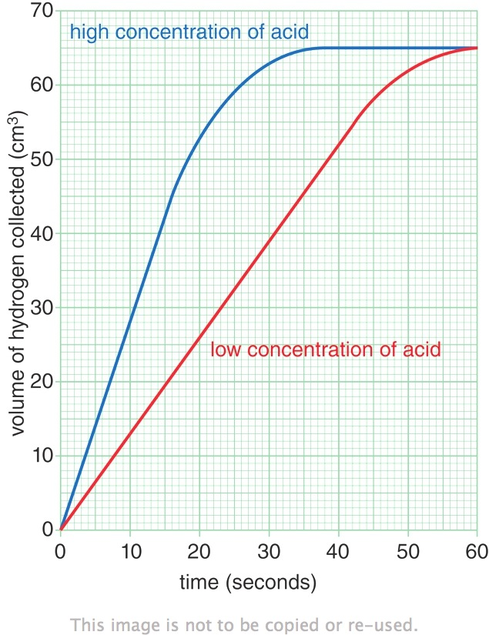**They used 0.1 g of magnesium ribbon with specific volume of diluted acid.**

**Next, they repeated the experiment using magnesium ribbon with the same volume of concentrated acid.**

**Their results are shown on the graph.**

1. Identify:

* The dependent variable: volume of hydrogen gas collected
* The independent variable: concentration of acid

1. Use the information on the graph to describe one way in which the two reactions are similar.

By the end of both 2 reactions the same amount of hydrogen gas was collected

1. Use the information on the graph to describe one way in which the reactions are different.

the high concentration of acid finished at 30 seconds and the low concentration of acid at 60 seconds

1. The faster reaction was caused by using a concentrated acid. Explain, in terms of particles and collisions, why a higher concentration acid causes a faster rate of reaction.

There are more particles in the same space, therefor collision is more likely to happen which would make the reaction faster