**Question one:**

Small lumps of marble chips were added to dilute hydrochloric acid in the apparatus shown in the diagram.

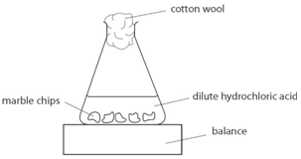The balance reading was noted as soon as the lumps were added, and again every 20 seconds. The experiment was repeated by using different sizes of the marble chips.

1. **Write the word equation for this reaction.**

**Caco3 + hcl cacl2 +h2o +co2**

1. **Suggest why a cotton wool was placed in the mouth of the conical flask.**

For the solution not to splash

y

**The results of the investigation were plotted on the graph as shown.**

Balance reading

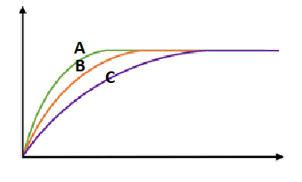

Time(seconds

x

1. **Label the X axis and the Y-axis**
2. **Label the marble chips with the smallest surface area.**

**Smallest surface area: c**

1. **Decide if the following statements are true or false:**
2. **Line A represents the results of the large chunks reaction. false**
3. **All the three experiments ended at the same time and caused the same mass loss. false**
4. **The reactions are the fastest at the beginning. true**
5. **The three lines turned flat because the students stopped collecting data. false**

**Question two:**

**Two 10g samples of marble of different sizes, A and B, were each reacted with 50 cm3 of diluted hydrochloric acid. The mass of carbon dioxide formed in each reaction was recorded and plotted to produce the graph below.**

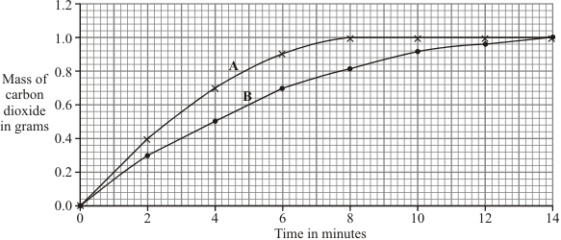

1. **Identify:**

* The dependent variable the mass of the carbon dioxide formed
* The independent variable the marble size

1. **Fil in the table below with the missing results.**

|  |  |  |
| --- | --- | --- |
| **Time/ min** | **Sample** | **Mass of gas produced/g** |
| **4** | **b** | **0.5** |
| **8** | **b** | **0.8** |
| **14** | **B** | **1.0** |
| **2** | **A** | **0.4** |

1. **How long did it take sample A to finish the reaction?** 8 min
2. **Explain the results of the investigation, in terms of particles and collisions.**

In a the particles collide quicker and more frequently than marble b

**Question three:**

**Some students were investigating how fast hydrogen gas is released in the reaction between magnesium and hydrochloric acid.**

**They used 0.1 g of magnesium ribbon with specific volume of diluted acid.**

**Next, they repeated the experiment using magnesium ribbon with the same volume of concentrated acid.**

**Their results are shown on the graph.**

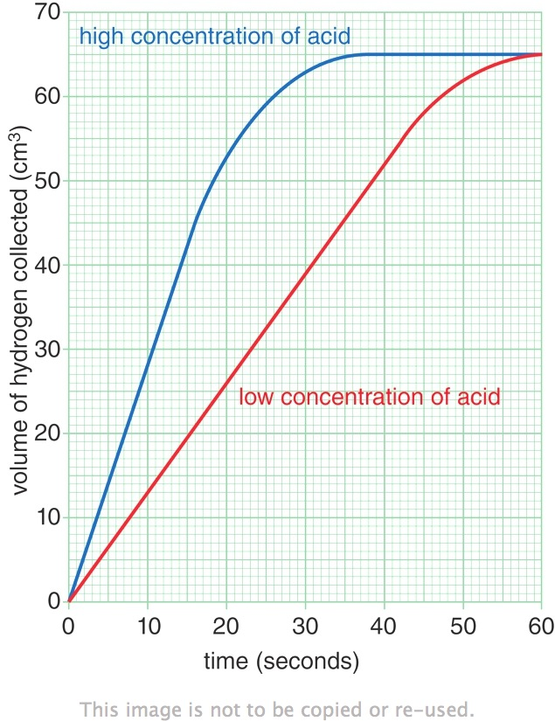

1. **How do you explain that the same volume of gas was given out in both experiments?**

**They both end at 65cm^3**

1. **The faster reaction was caused by using a concentrated acid. Explain, in terms of particles and collisions, why a higher concentration acid causes a faster rate of reaction.**

**There are more particles in a higher concentration acid so they will collide more**

**Why do you think the reaction with the diluted acid got slower between 45-55 sec?**

**Most of the magnesium reacted already**