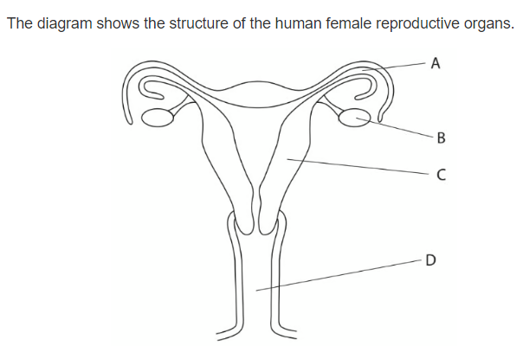**Question 1 :**

* Which letter represent the site of fertilization …………A……….
* Which letter shows were the fetus usually develop …………D………….
* Name organs :

B : ………Ovary……………………

A : …………Fertilization………………….

C : …………Uterus………………….

* Draw an x on the diagram to show where implantation takes place .
* State what is meant by the term menstruation .

The process of bleeding

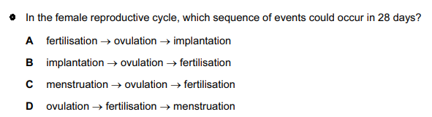……………………D……………………………………………………………………………….

**Question 2 :**

1. Khalil is one of three boys , his parents are expecting another child and they are certain it will be a girl . Explain why they are wrong ? *( 1 marks )*

Children inherit half of the chromosomes from their mother, and the

other half from their father. Since they have three boys this means that the next child would most likely be a boy, because the (y) sperm would reach the egg faster than the (x) one.

1. Copy and complete the diagram to show how the sex of the baby is inherited.

*( 4 marks )*

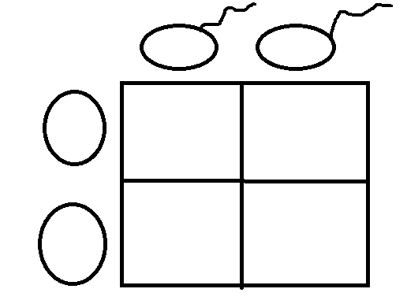

**xy**

**xx**

**xy**

**xx**

**Question 3 :**

Arrange these objects in size order, starting with the largest. *( 2 marks )*

Nucleus chromosomes gene cell DNA

…cell, nucleus, Dna, gene, chromosomes.

**Question 4 :**

The diagram shows an egg, a sperm and a fertilized egg. *( 3 marks )*

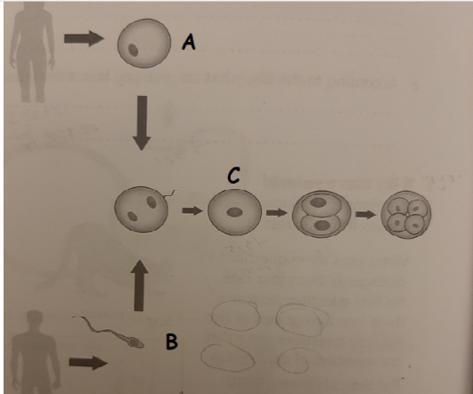Label the diagram to show how genes from each parent get into all an embryo’s cells

embryo

zygote

Fertilized egg (2 sets a new combination

Sperm (1 set random selection)

Egg (1 set random selection)

2 sets of genes in

Each cell

2 sets of genes in

Each cell

**Question 5 :**

Demonstrate how an egg cell is adapted to its function .

An egg cell has adapted to its function by the presence of cytoplasm, which increases its surface area to make it easier in the development of the embryo within it.