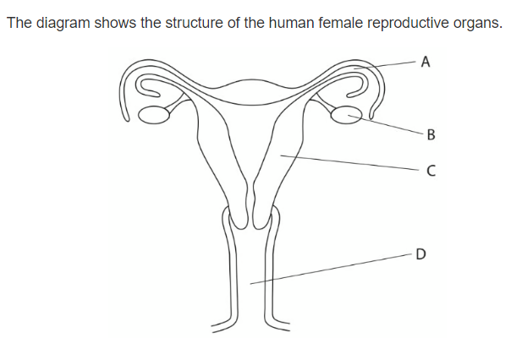**Question 1 :**



* Which letter represent the site of fertilization ………A……….
* Which letter shows were the fetus usually develop ………D……….
* Name organs :

B : ……………ovary………………

A : ……………oviduct……………

C : ……………uterus……………

* Draw an x on the diagram to show where implantation takes place .
* State what is meant by the term menstruation .

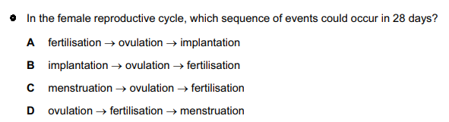… Menstruation is the monthly shedding of the lining of your uterus. ………………D………………

**Question 2 :**

1. Khalil is one of three boys , his parents are expecting another child and they are certain it will be a girl . Explain why they are wrong ? *( 1 marks )*

…Because it is a 50% chance for them to get a boy and 50% chance for them to get a girl.



1. Copy and complete the diagram to show how the sex of the baby is inherited.

*( 4 marks )*

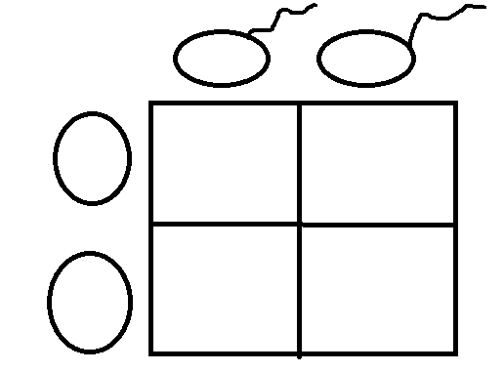



**Question 3 :**

Arrange these objects in size order, starting with the largest. *( 2 marks )*

Nucleus chromosomes gene cell DNA

Cell, Nucleus, Chromosomes, DNA, Gene.

**Question 4 :**

The diagram shows an egg, a sperm and a fertilized egg. *( 3 marks )*

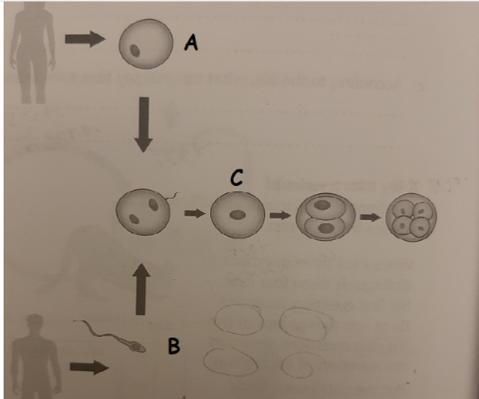Label the diagram to show how genes from each parent get into all an embryo’s cells

Sperm(23 chromosomes, 1 set of genes)

Zygote(46 chromosomes, 2 sets of genes)

Egg(23 chromosomes, 1 set of genes)

**Question 5 :**

Demonstrate how an egg cell is adapted to its function .

Eggs have a large food store which the embryo needs for growth and a jelly layer to attract the sperm.

