***Biology Grade 9 IB Report on Sexual and Asexual Reproduction in Flowering Plants.***

Written by: Ishmail Mustafa, Julie Zeidan, Makram Sunna and Ahmad Abdalatif

1. In sexual reproduction, plants reproduce through flowers plants’ seeds, whereas asexual reproduction occurs through the spread of spores from the asexual plant.

Plants that sexually reproduce are flowering plants, with the female organs and male counterparts, Unlike asexual plants that do not grow flowers. As a result, these non-flowering plants need to reproduce through the spread of their spores, so no seeds or binary organs are required by the plants. An example for each is the angiosperm family, and the conifer family.  ***-Julie***

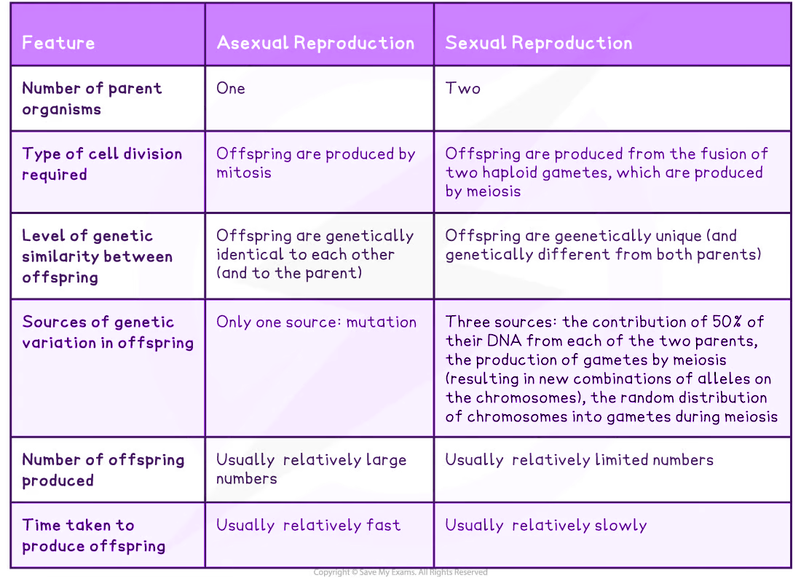

*Citation: Cambridge IGCSE Biology Course Book, 3rd Edition*

4. The Differences between structures of Insect Pollinated plants and Wind Pollinated plants, and adaptations between them.

In nature there are many ways to which a plant can undergo the process of pollination, these methods include Wind Pollination and Insect Pollination. Here we will be examining the difference in structures and why or how these plants adapted to be like this.

Firstly, as you are aware, to go through fertilisation plants need to move the male gamete to the female gamete. The first step of this is to pollinate, which is where our methods of pollination come in.

**Pollination through insects:**

One way that millions of plants use to pollinate is through insects. The plant attracts the insect usually using bright colours and smells, and when the insect lands on the plant, little pollen grains stick to the insect, and as the insect leaves it takes the pollen with it. The insect then goes to another flower, where the stigma is sticky, and many pollen grains will stick to it, where they are then taken by the plant so that it may undergo fertilisation (please note, this will only occur if the plants are of the same species.)

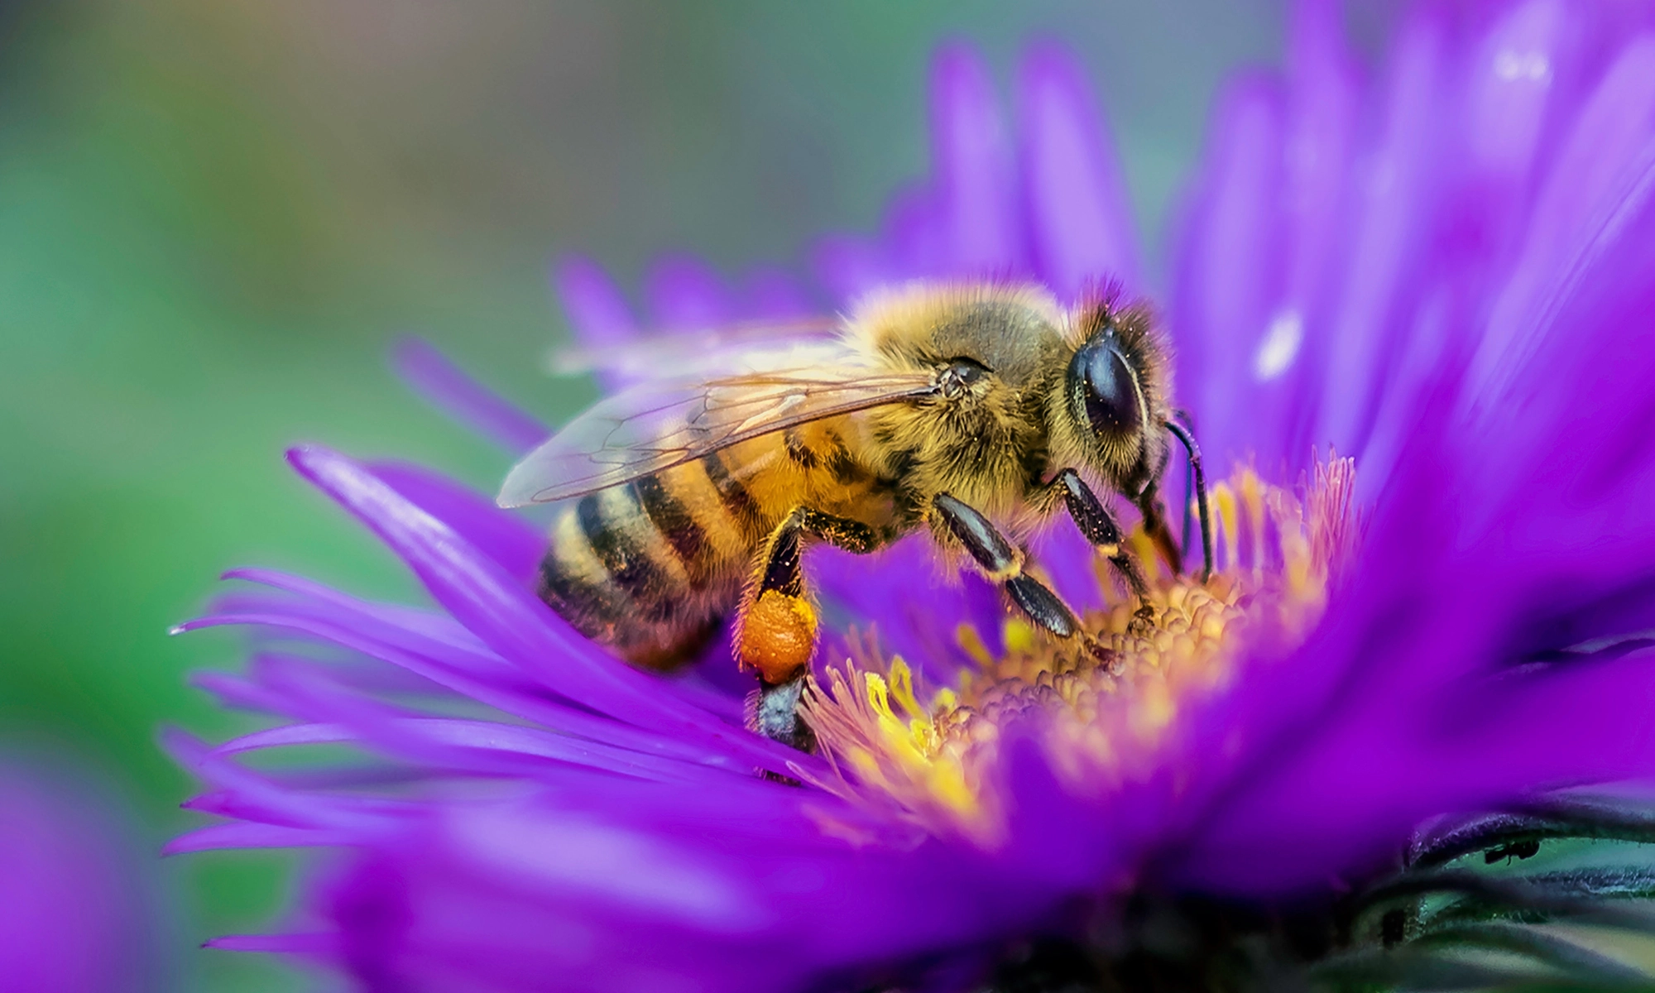

Source of the image: https://ideas.ted.com/bees-can-remember-human-faces-and-7-other-surprising-facts-about-these-important-insects/

A common example that is used is the bee. A bee will fly towards a plant once it has been attracted, and upon landing on the plant, it will pick up all the pollen grains using its little hairs. The bee then heads to another plant, looking for nectar. When the bee lands on the new plant, the pollen it picked up will get stuck to the stigma, and the plant will then undergo fertilisation. The bee will get its nectar too, so both parties in the ecosystem will benefit.

**Pollination through Wind:**

Another method that plants use to pollinate is through wind. Unlike the colourful bright petals of an insect pollinated plant, Wind pollinated plants are often bland as they have no evolutionary need or adaptation to have colourful petals which attract animals. Instead, these plants are often feathery and light, which lets them flow in the wind and catch other pollen grains so that they can fertilise. They produce a lot of pollen, and when a gust of wind comes, the pollen will fly with it it, other plants catch them with their feathers, and the process of pollination is now complete.

**Cross-Pollination: a journey from an Anther of one plant to a Stigma of another:**

Plants often use cross pollination as a method of reproduction, which is when pollination occurs with two different plants of the same species. This works through the methods mentioned above, Pollination through wind and pollination through insects, other ways this can happen are through animals and water. The pollen grains from an anther of a plant get caught in whatever transportation method the plant has adapted to use for them, and they will then be moved. Eventually pollen grains will reach their destination: a different plant’s Stigma. It is crucial for the plant to be of the same species otherwise fertilisation will not occur.

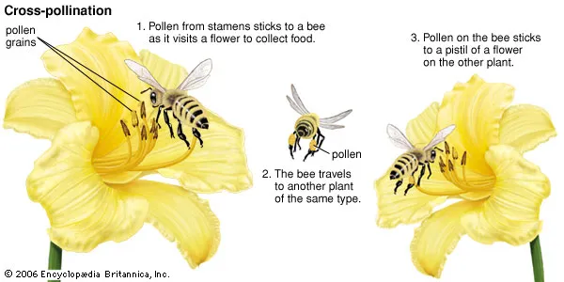

Source for the image: <https://www.britannica.com/science/cross-pollination>

**Implications to a species of Self Pollination and Cross Pollination in terms of variation, capacity to respond to changes in the environment and reliance on pollinators:**

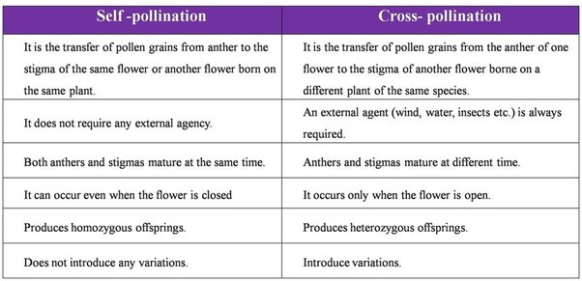Source: <https://qph.cf2.quoracdn.net/main-qimg-a055efee55f409041be3f188ff938e16-lq>

If you look at the table, you can see differences between Self-Pollinated and Cross-Pollinated plants, but how do these differences help them?

*Variation*

Cross-Pollinated Plants produce much variety as the new plant created after fertilisation will have genes from both parent plants. This creates a new set of genes which will once again be passed on and on and so forth. Self-Pollinated Plants however, produce no variation at all, the new plant will be a copy of the parent plant as there will be no new genes to mix with.

*Capacity to respond to changes in the environment*

Plants that Self-Pollinate will have less genetic variation, which makes them much more susceptible to environmental changes as things that they may have adapted to in the past will no longer be there, and instead new issues will arise. Furthermore, as the rest of the ecosystem evolves, and animals that used to assist these plants also evolve, the plant will simply no longer be fit for the environment after some time.

Plants which Cross-Pollinate will have more genetic variation, and thus just as the theory of evolution states, the plant more fit for survival will reproduce, and the rest will die out. The fit plants will pass on their genes which helps plants continuously adapt to the environment over time.

*Reliance on Pollinators*

Self-Pollinated Plants do not rely on pollinators as they can pollinate themselves.

Cross-Pollinated plants heavily rely on pollinators may they be wind, water, animals or insects, as this is the only way they can move their pollen grains to spread their genes.

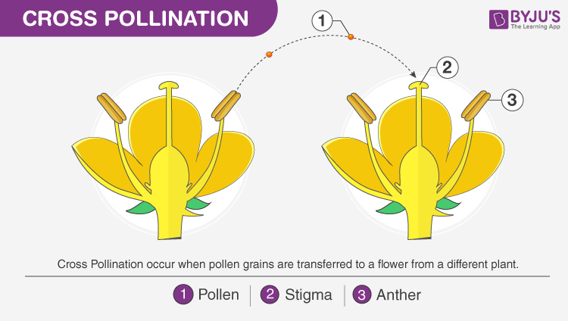

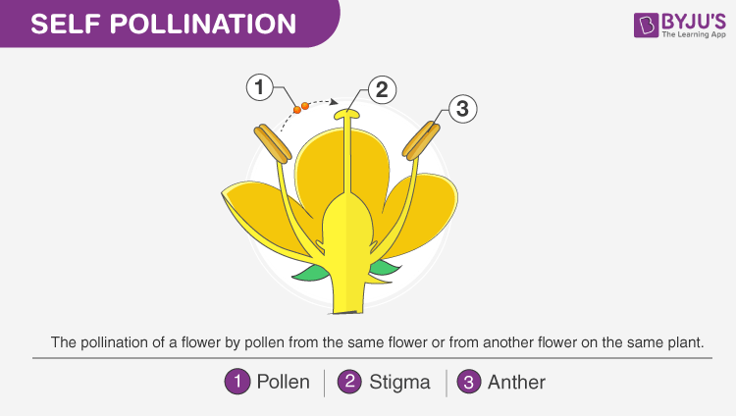

Identifying the different parts of a seed:

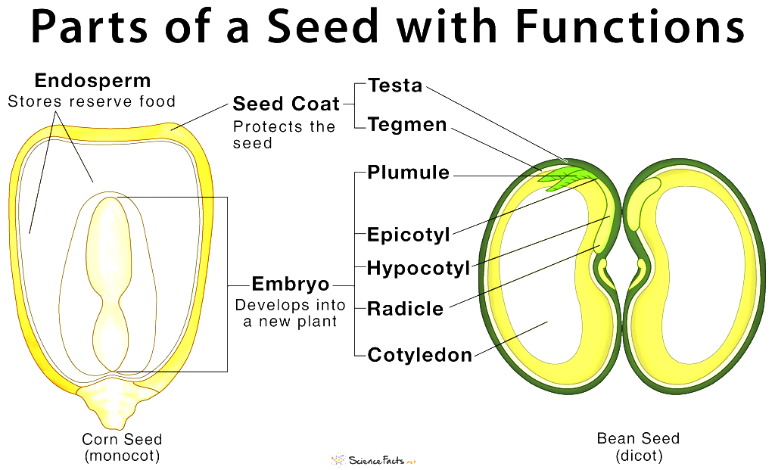

Cite: https://www.sciencefacts.net/parts-of-a-seed.html

To begin, the testa is the outer layer of a seed, it is a protective covering and the seed coat. A cotyledon is the first part of the leaf which begins to emerge after pollination, it’s commonly referred to as the storage unit of the leaf as it provides the nutrients needed to different parts of the embryo. The radical is the embryonic root of the cell, which eventually grows and matures into the root system of the plant. The Plumule is a part of the embryo that emerges and grows into a little shoot; a shoot is a baby plant consisting of a stem, and few leaves. The hypocotyl is the part of the seed that emerges into the beginning part of the stem. Whereas the epicotyl is the region of a seedling stem above the stalks of the seed leaves of an embryo plant. The tegmen is the inner part of the seed coat, it’s thin, papery in nature, and delicate.

**The environmental conditions that affect the germination of seeds:**

**Water:** Water plays a major part in the process of seed germination. It helps by providing necessary hydration for the vital activities of certain seed organelles, and provides oxygen in a dissolved form (aqueous) for the growing embryo. Moreover, it helps soften the seed layers and allows for more permeability for the layers of the seeds. The plant would not continue to grow without consistent watering.

**Temperature:** Temperature affects moisture, hormone production, and enzyme production. In order for a seed to grow in a healthy manner, the seeds need to retain water and maintain moisture. Increased temperature would make the water absorbed by the seed evaporate, which would negatively impact the growth of the seed.bur

**Parts of a plant:**

Stamens are flowering plants' male reproductive organs. They are made up of an anther, which is the site of pollen development, and a stalk-like filament, which transmits water and nutrients to the anther and positions it to aid in pollen dispersal.

The filament's primary function is to transport nutrients to the anther for the development of the anther and pollen grains

Anther: The part of the stamen that produces pollen.

Carpel is the female reproductive organ of flowering plants that contains ovules and is required for its protection, efficient fertilization, and the development of various types of fruits

Style: It is a tube-like structure that connects the stigma and the ovary. The style is especially important during fertilization because it not only generates the pollen tube but also prevents incompatible pollen from entering the ovary.

The stigma is found in the flower's gynoecium. Its primary function is to attract pollen grains from the air with its sticky tip in order for reproduction to occur.

An ovary's function is to prepare the ovules for fertilisation, protect developing zygotes, and mature into a seed-bearing fruit

In seed plants, the ovule is a component of the female reproductive organ. It is the site of the formation and confinement of female reproductive cells, and it is what eventually develops into a seed after fertilisation, only for the seed to ripen and produce a fully mature adult plant.

Sepals are green in color and are only found in flowering plants as a vegetative part of the plant. They are the outermost layer of a flower that encloses the flower bud and are known as the calyx. They are the leaf-like structure that comprises a flower

Petals are modified leaves that surround a flower's reproductive parts. To attract pollinators, they are frequently brightly colored or unusually shaped.

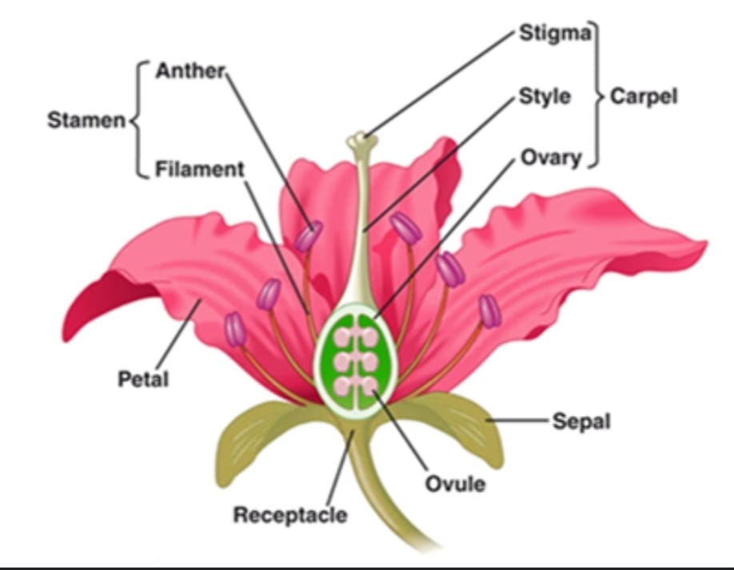

**Example of asexually reproducing plant**

The potato plant reproduces asexually through vegetative propagation. Vegetative propagation is the process by which new plant offspring are formed from vegetative plant parts such as roots, stems, and leaves. Potatoes have small eyes/tubers that give rise to leaves.