THE DAILY NEWS

**THE ALIENS HAVE LANDED!**

Celina Haddadin -Staff reporter

Sun, March 5th, 2023

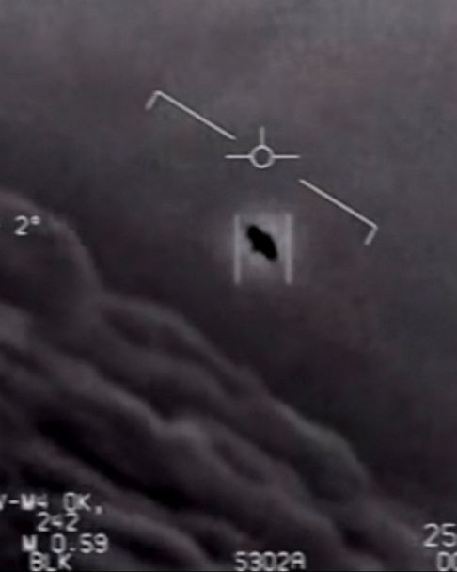USA-Three new reports of weird floating objects in the sky! could these objects be a threat to this world? And the real question is, could this object possibly be a UFO? after several citizens spotted one of these objects around an empty land around Nevada’s National Park, at around 6:30 the government action was to shoot down this “UFO”, they confirmed that it took them a while to get to the object but when they did they claimed to have found it empty, could the aliens have escaped? Or is the government hiding the truth?

Now people in Las Vegas and the rest of Nevada and surrounding states are pancaking and started to leave their homes or hide their bunkers after collecting a huge amount of food and medical supplies in addition to huge amounts of water, afraid of this wild vague invasion of strange creatures and asking the government to explain their findings and reassure the people.

**Walmart shelves**

This caused the market shelves to be almost empty, On the other hand, officials are not accepting to comment on this situation until they gather more information.

**Government released photo**

“We have seen a grey-black ship-like looking object with lights in the playground next to our house, we are so afraid and scared so we decided to gather our things and go to my parent’s house in California, “said a man that lived with his wife and kids in western street house 17. This was confirmed by hundreds of other witnesses with the same descriptions and fears as the others.

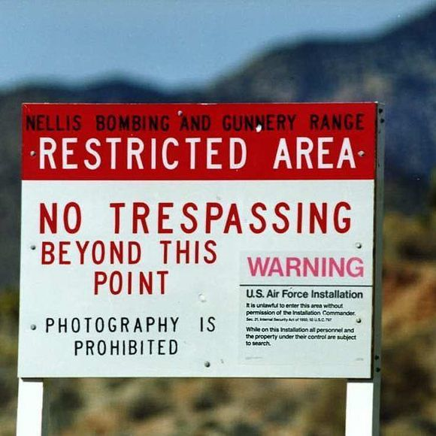“the government must tell us what is happening, they must tell us about area 51, “A woman working in the library said.

People have had wild theories about area 51 for decades but now they have all risen to try to know the truth could this area be the government secret facility for aliens and have they known about their existence for a long time as suspected by the people? But there is something for sure going on about area 51, something odd…

These theories and sightings of aliens haven’t happened in around 20 years. but, NOW they are true, the only thing that we know is that we can’t predict what aliens are doing or planning to do with us or our planet, and the worst thing to do is panic. So, you should try to stay calm and wait for official instructions and guidelines, and don’t forget to urgently report any strange incidence or sightings, and let’s just hope for the best.

**Area 51**