Aliens invade earth

Salma Nabulsi

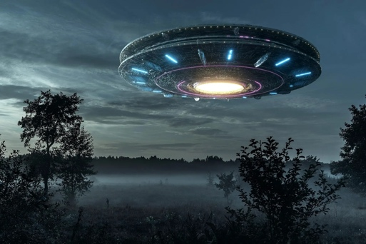

The space alien invaders are near

They are approaching planet earth

The dark clouds are hanging

The lights went off in the city

In the streets there is commotion

The radios and tv announcements are scared

Telling us to run for our lives

Fires in all cities and towns

The sirens of vehicles going to hospitals

The ambulances picking up the sick and hurt

The air full of smoke and burning scent

The fire fighters are busy working and saving people

Strange planes appear flying all over

The sound of crackling machines

Reports of the alien’s presence

All over the country and over

The lands, seas, and oceans

The railroads are knocked out

The airports are shut down

The houses on fire and ruined

All bright colors and lights

Flashing all over the sky

Lighting the massive clouds

The sounds of the alien vehicles

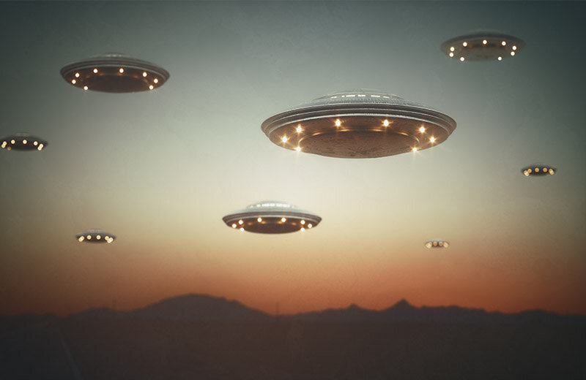buzzing and getting louder

they are flying lower and lower

they are in huge great numbers

the space aliens have landed…

The earth has been invaded…