Aliens Invade Earth

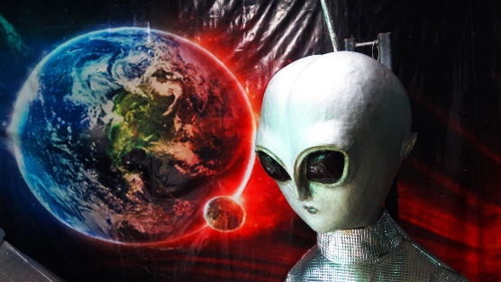Once upon a time there were three children playing together with their toys in the playground, they were happy until they saw a large alien plane was flying in the sky there were three of them flying.

Until one of the children said: “is that an alien plane?”

All of the children said: “yes, it is!”

The children were scared because of it, they thought that they’re going to die

a few minutes and the aliens landed on the ground all of the children ran away and hid behind a big bush to see what will happen, and then a huge number of aliens get off their plane. They were destroying everything the bushes the slides and the swings until they saw our toys that we were playing with.

The leader of the aliens said: “Hmm, there were people in here not just us!”

One of the aliens said: “yes leader! There were three people here because of their toys”

The leader of the aliens said: “I think there were children here because the toys are for children’s”

The leader was smart enough to know how much people are there, the children were very scared because the aliens will know that they are here and kill them.

One of the children said: “I don’t want to die I’m still young”

One of the children sneezed and the aliens heard the voice, and they started to explore the sound was from where and who made it. Until one of the aliens found the children behind the bush, the alien shouted to the leader to come and see, the leader came and saw the children and said: “what are you doing here kids? That’s our world now.”

The children said: “no its our world we lived here for many years!”

The aliens said: “okay but now its our world you need to leave right now or we will kill everybody in this world!”

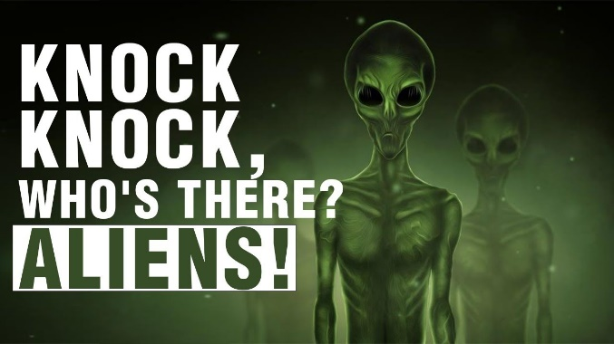With the children were a loud speaker and they made a plan to scare the aliens to leave the earth, they putted the bomb sound to scare them like it is the end of the world, they started the plan and turn on the speaker.

The leader said: “oh no what’s that sound is that the end of the world or there is a war?”

One alien said: “I think it is the end of the world oh no we’re going to die let’s move from here and go back to our world!”

The aliens went back to their world, and the children were very happy to do this and they continued playing, they will not come back here anymore.