**Aliens invading earth**

Have you ever thought that aliens would invade earth? Or you would be able to see aliens?

Hi my name is Alexandra, I’m 13 years old, I always loved exploring and hunting it was my wishing hobby, many didn’t believe in aliens but I know they exist and no one could change my mind no matter what. 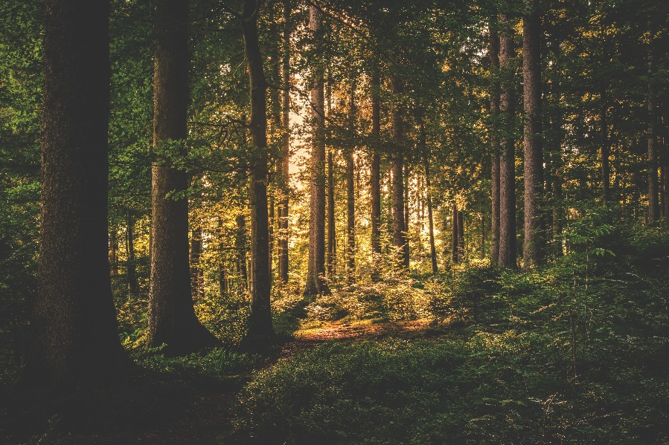

**I was walking in the deep dark forest with my friends, Leo and Salem, suddenly Leo pointed out something like a cave and said,**

**“Guys look a cave! Can we go inside please Alexandra please!”**

**“Ok fine it must be fun I guess, but this isn’t my first time in this forest or on this route I’ve never seen that before.” I said confusedly.**

**We were on our way to the suspicious cave I’m confused I’ve been on this route billions how could this cave randomly appear?**

**“Guys I’m scared”. Said Salem**

**“Why do you always have to be so scared, what are you going to do cry”. Said Leo**

**“Guys stop fighting and Salem man up also Leo you don’t have to be mean about it”. I said**

**We came and stopped at the front of the cave, I have never seen anything like it, it had the structure of an aliens face, we entered, there was a door with engraved symbols on it, we came to open it but it was locked.**

**We started to look around, suddenly I found a lever looking metal, it was very rusty.**

**“These are like one of those video games that I play, it has to be a puzzle”. Said Salem**

**“True”. I walked towards the door there was a hole I put the stick in it and pulled it, the door opened, it looked like a lab with potions on the table and pictures of aliens on the wall.**

**We started looking around,**

**“Guys look a lever” said Leo, he pulled it.**

**“No don’t do it” I said desperately.**

**A secret door showed up with a big red button that said “DON’T PRESS”**

**One of the boys walked up to it about to press it, of course they did right then aliens were running out of there like it was about to explode**

**All three of us shout “ALIENS!”**

**Before we knew it they were all over town invading the earth wrecking buildings.**

**We went outside, screams from all around and trees on the floor.**

**“Salem why did you press the button” I said worriedly**

**“I didn’t mean for this to happen.” said Salem**

**“I can get used to this I think” I said**

**We were scared but trying to hide it.**

**The next day walking around town was worse than the day before.**

**Aliens were running everywhere this was my fault it looked like they increased not only in size but numbers, I had a small job to gain money at an ice-cream shop downtown, on my way there; there were aliens eating all the ice cream I couldn’t but walk up and ask why are you doing this they bowed down for me and called me their master**

**“You are the one that let us free thank you” one of the aliens said.**

**“No, you are mistaken my friend let you out”. they were still bowing, I mean I could get used to this.**

**After that day everyone gave me a death stare while the aliens would freeze every time they look at me sometimes they would follow me and it was kind of scary.**

**The aliens never stopped they did the same with my friends this was all a misunderstanding promise.**

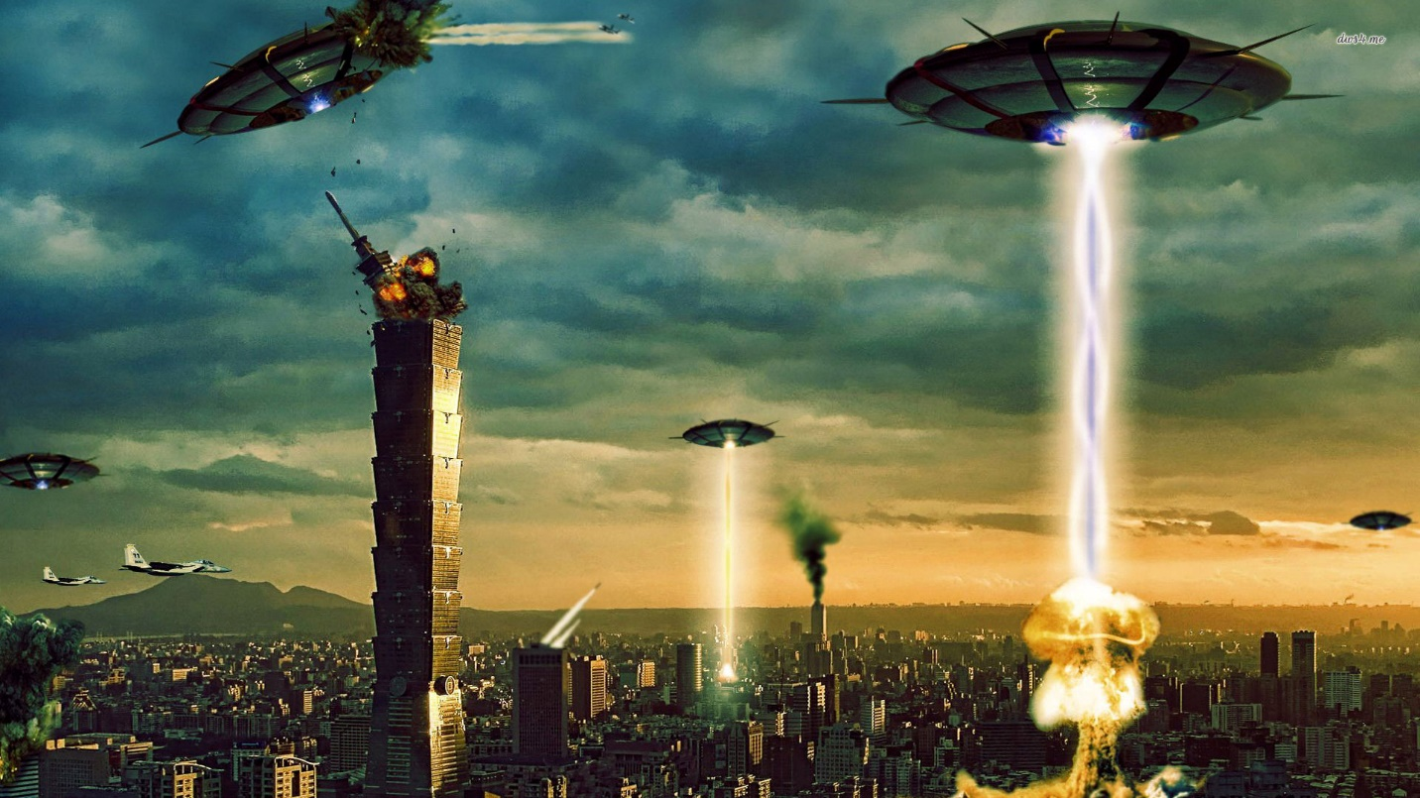

[This Photo](https://21astrans.wordpress.com/2020/04/30/cientificos-proponen-esconder-la-tierra-para-evitar-una-invasion-extraterrestre/) by Unknown Author is licensed under [CC BY-SA-NC](https://creativecommons.org/licenses/by-nc-sa/3.0/)