Aliens have officially invaded earth, and it is known everywhere over news websites, and social media.
Some believed it some thought it as a myth, but it is true aliens exit and they are not as nice as they say in the fairytales, they have taken over earth. All countries combined and fought together but all lost due to the alien’s extreme magic powers.
Aliens are also very mean and bully humans currently all food and water are rapidly getting stolen and very few foods and water are left and they are ruining buildings every important artifact and all the banks money has been stolen, and aliens have been seen disguising them selves as humans to steal their wallets phones and many important things
Currently all Arabic countries hid in a spot right in the middle of all Arabic countries and people in Europe and Africa did the same, but everyone knows this won’t last for long.

All top scientists are trying everything in their will to kill the aliens all military forces are protecting the hiding spots from the aliens all technology experts are inventing a machine that will hopefully keep humans alive, and all top Nasa experts are trying to figure out how did aliens come to earth why did aliens come to earth and are sending their best spaceships astronauts and telescopes.
We have messages from people who have encountered aliens this is a message from Layla a little girl who saw an alien take her food ‘I saw it I saw an alien it was so scary it came out of a portal thing and took the whole bowl of food, and when it saw me it smiled so creepily and took an empty bowl and smashed it on the floor it was so scary’ and another message from an old man who was at a gathering and aliens almost took his waking stick ‘they tried to take my stick I was siting in the room alone and then out of nowhere an alien popped out of a portal, and tried to take my waking stick if I hadn’t called for help my back would be broken .
The government has just announced an official alien message which reads “hdd kdjgdh kjydtdv kejdg jdgdgv ienrjkr iiuybmb knvjr kdegr kfjrjgvvrke kyfbvemf kchfvrj dhdhnh ugjhgfi iufiry gjfs kfdjk dfygfeh kfgy yfvvhkf fygkfvr ougferog lsf hft “ which means we aliens have taken over earth and have no mercy we know where all your hiding places are, but we didn’t attack because we were stealing all your belongings and now that we have stolen everything we will attack every area one by one and will kill anyone who steps in our way be ready.
This was the message we got from the aliens, and it has been broadcasted everywhere which is the only thing the aliens wouldn’t take aliens have taken the internet but not the broadcasts because they want everyone to know.
We hope you are all doing all right and we will inform you soon.
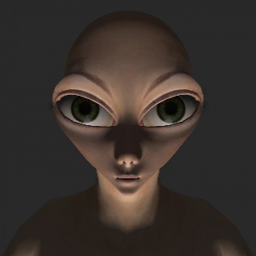
Last seen picture of alien

s

By: karmel
From: Read and believe

