**Aliens Invade Earth**

July 1999, Summer Day, I was sitting in the wooden porch, having a delicious lunch with friends and enjoying the scenery of the beautiful mountings. The weather was nice and the winds were strong ,crashing into our faces. When suddenly my friend Jimmy shouted, “look there is something strange in the horizon, look guys.”

“It’s nothing, it’s probably a camp fire or something”. Said Adam.

“Look again guys, a huge smoke is coming out of that spot and there are strange lights next to our wooden cabin.” Shouted Jimmy.

“Wait, you are right! Something strange is happening, what should we do?” Adam asked.

“Let’s check it out!” Shouted Jimmy

“Are you out of your mind! Something bad might happen, you never know.” Cried Ryan.

“If you guys are not doing it, I will go by myself” Jimmy said.

Ryan Said, “Fine, then let us all go, what’s the worst thing that could happen.”

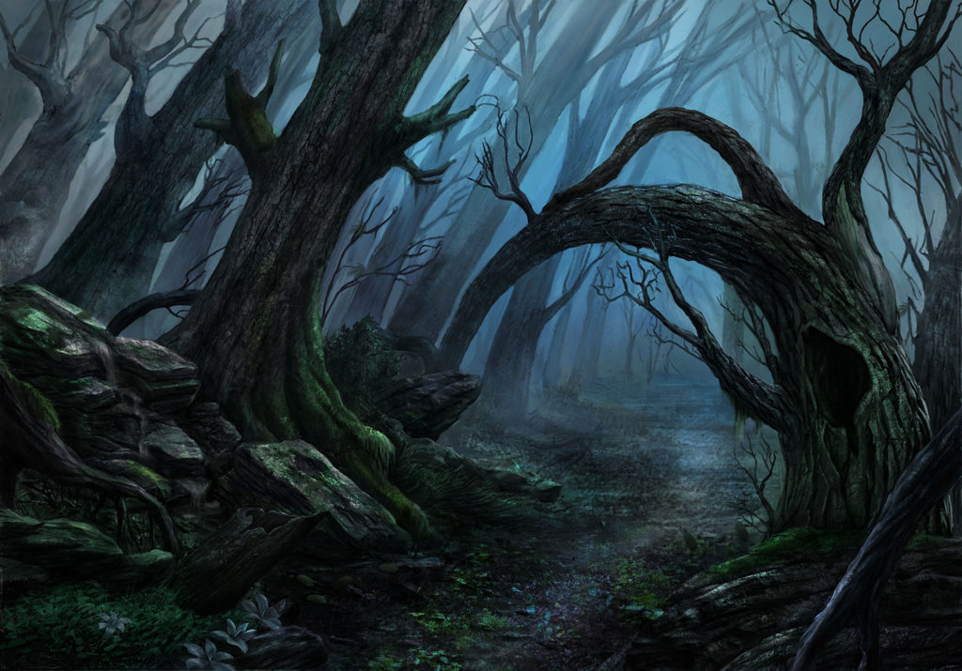

The three of us walked into the woods towards the direction of the smoke, it took us one hour to get there.

“Finally, we are here, it is huge,” said Adam

“Wow! this thing looks huge indeed, is it made out of metal?” Jimmy asked.

“It is solid and rough; it looks it is made out of strong dark metal.” Replied Ryan.

“Ouch!” that thing is really hot, it burns! Do not touch it guys.” shouted Jimmy.

“What do you think it is?” asked Jimmy.

“You guys will say I am crazy, but this thing looks like a spaceship, Adam stated.

Ryan breathing heavily, “Oh No! Is that a dead body, lying on the ground!”

Just as we were running away to the opposite direction of that dead body into the forest a strange light flashed from above, lighting up the whole area, and we felt like it’s pulling us upwards.

“Hold on tight to the trees next to you guys” shouted Jimmy “We are being abducted by an alien ship!”

