On the 21st of march2023 at 2:25pm a large group of aliens randomly show up running from the cost of America towards America downtown.

The cost of America is known for its famous and very secretive area which is called area 51 it is one of the most secretive places on planet earth.

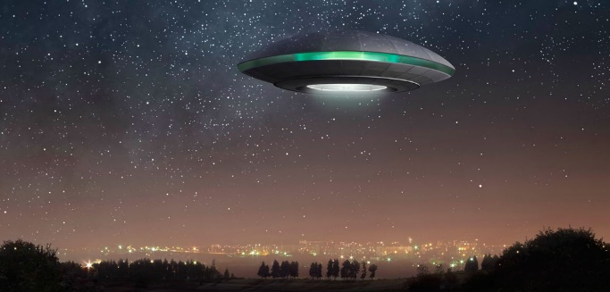But people described those alien like creature as if they were like zombies but with very big dark eyes and very tall also with extremely large heads they were tariffing.

Some of the people that Witnessed the seen saw very large plate like things that were flying and it looked straight out of a movie ,the police were trying there best to stop the spreading of the aliens .All the people close to the invasion evacuated very fast.

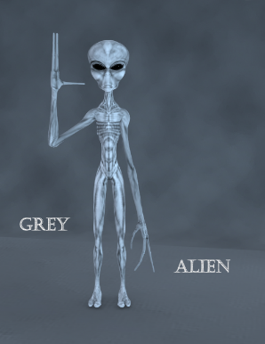The aliens were destroying buildings and they were all carrying electronic guns, The mystery is still there we don’t know where they came from and WE will never know but the people that are interested I encourage you to go deeper into this mess.

Please protect your self from the aliens until experts

THANK YOU.