Aliens invade

Lights in the sky are not what they seem

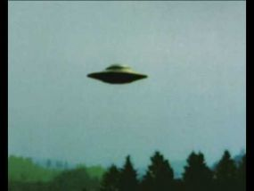but they are still as seeming less as a

night sky dream.

The lights which I thought were stars in the sky

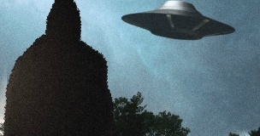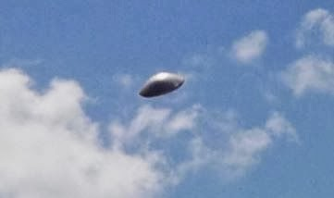are contorting into many and many big lies,

a metal saucer flies in the sky destroying

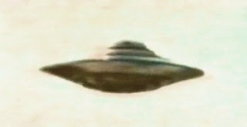anything it sees and doesn’t like

I run, try to hide but they always seem

Just so close as if to grab me from behind.

🛸

Nabeel Ammari