

**Worksheet**

**Converting Binary to Decimal**

Name: Grade: 7 ___________

**Transistors:**

* The computer’s microprocessor is a small component made up of millions of tiny electrical switches.
* Transistors can be only either **On or Off**

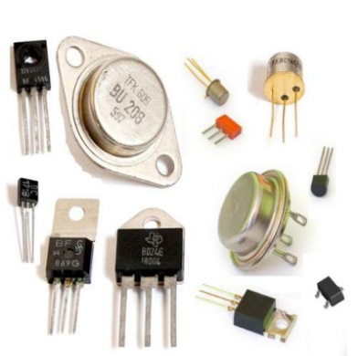

* A computer stores and processes data in a simple format because it only understands these two states On **and Off**

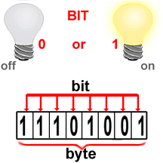

**Binary system:**

* The binary number system only uses zero and one to represent data.

**Byte:**

* Byte is the basic word that a computer uses.
* A byte is eight bits’ long

**Measuring computer memory:**

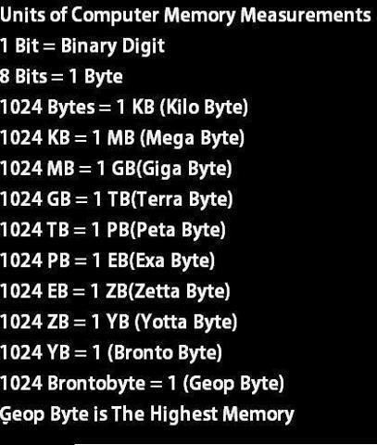

Write each binary number as a decimal number:

|  |  |
| --- | --- |
| 1- Binary = (10011) 2  Decimal = 19  4 3 2 1 0  2 2 2 2 2  1 0 0 1 1 =  2x2x2x2= 16  2x1= 2  1  16+2+1=19 | 2- Binary = (10000) 2  Decimal = 16  4 3 2 1 0  2 2 2 2 2  1 0 0 0 0  2x2x2x2=16 |
| 3- Binary = (101011) 2  Decimal =43  5 4 3 2 1 0  2 2 2 2 2 2  1 0 1 0 1 1  2x2x2x2x2=32  2x2x2=8  2  1  32+8+2+1=43 | 4- Binary = (1111) 2  Decimal = 15  3 2 1 0  2 2 2 2  1 1 1 1  2x2x2=8  2x2=4  2  1  8+4+2+1=15 |
| 5- Binary = (110011) 2  Decimal=51  5 4 3 2 1 0  2 2 2 2 2 2  1 1 0 0 1 1  2x2x2x2x2=32  2x2x2x2=16  2  1  32+16+2+1=51 | 6-Binary = (11000) 2  Decimal = 20  4 3 2 1 0  2 2 2 2 2  1 1 0 0 0  2x2x2x2=16  2x2x2=8  16+8 = 20 |