

**Worksheet**

**Converting Binary to Decimal**

Name: AWN SWEISS Grade: 7G

**Transistors:**

* The computer’s microprocessor is a small component made up of millions of tiny electrical switches.
* Transistors can be only either **On or Off**

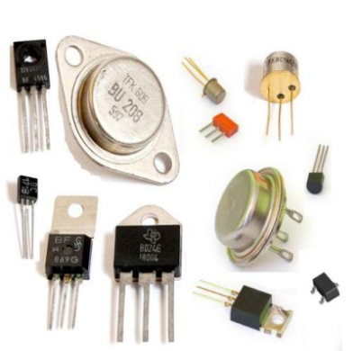

* A computer stores and processes data in a simple format because it only understands these two states On **and Off**

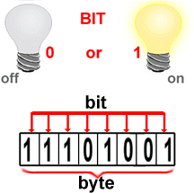

**Binary system:**

* The binary number system only uses zero and one to represent data.

**Byte:**

* Byte is the basic word that a computer uses.
* A byte is eight bits long

**Measuring computer memory:**

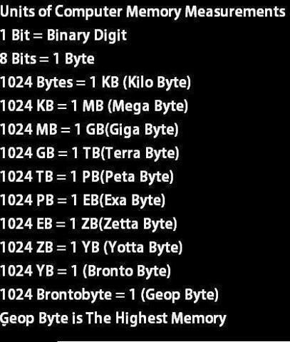

Write each binary number as a decimal number:

|  |  |  |  |  |  |  |  |  |  |  |  |  |  |  |  |  |  |  |  |  |  |
| --- | --- | --- | --- | --- | --- | --- | --- | --- | --- | --- | --- | --- | --- | --- | --- | --- | --- | --- | --- | --- | --- |
| 1- Binary = (10011) 2  Decimal =   |  |  |  |  |  | | --- | --- | --- | --- | --- | | **1** | **0** | **0** | **1** | **1** | | **16** | **8** | **4** | **2** | **1** |   **16+2+1=19**  **(19)** ¹⁰ | 2- Binary = (10000) 2  Decimal =   |  |  |  |  |  | | --- | --- | --- | --- | --- | | **1** | **0** | **0** | **0** | **0** | | **16** | **8** | **4** | **2** | **1** |       **(16)** ¹⁰ |
| 3- Binary = (101011) 2  Decimal =   |  |  |  |  |  |  | | --- | --- | --- | --- | --- | --- | | **1** | **0** | **1** | **0** | **1** | **1** | | **32** | **16** | **8** | **4** | **2** | **1** |   **32+8+2+1=43**  **(43)** ¹⁰ | 4- Binary = (1111) 2  Decimal =   |  |  |  |  | | --- | --- | --- | --- | | **1** | **1** | **1** | **1** | | **8** | **4** | **2** | **1** |   **8+4+2+1=15**  **(15)** ¹⁰ |
| 5- Binary = (110011) 2  Decimal =   |  |  |  |  |  |  | | --- | --- | --- | --- | --- | --- | | **1** | **1** | **0** | **0** | **1** | **1** | | **32** | **16** | **8** | **4** | **2** | **1** |   **32+16+2+1=51**  **(51)** ¹⁰ | 6-Binary = (11000) 2  Decimal =   |  |  |  |  |  | | --- | --- | --- | --- | --- | | **1** | **1** | **0** | **0** | **0** | | **16** | **8** | **4** | **2** | **1** |   **16+8=24**  **(24)** ¹⁰ |