

**Worksheet**

**Converting Binary to Decimal**

Name: Grade: 7 ___________

**Transistors:**

* The computer’s microprocessor is a small component made up of millions of tiny electrical switches.
* Transistors can be only either **On or Off**

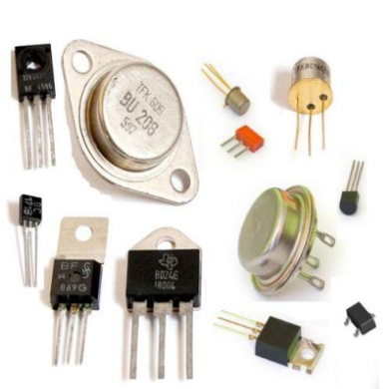

* A computer stores and processes data in a simple format because it only understands these two states On **and Off**

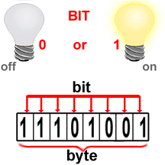

**Binary system:**

* The binary number system only uses zero and one to represent data.

**Byte:**

* Byte is the basic word that a computer uses.
* A byte is eight bits’ long

**Measuring computer memory:**

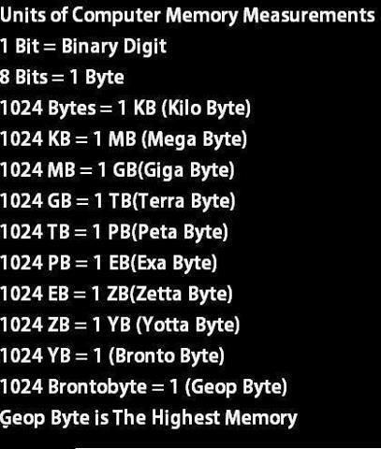

Write each binary number as a decimal number:

|  |  |
| --- | --- |
| 1- Binary = (10011) 2  Decimal =16+0+0+2+1=1910 | 2- Binary = (10000) 2  Decimal =16+0+0+0+0=1610 |
| 3- Binary = (101011) 2  Decimal =32+0+8+0+2+1=4310 | 4- Binary = (1111) 2  Decimal =8+4+2+1=1510 |
| 5- Binary = (110011) 2  Decimal =32+16+0+0+2+1=5110 | 6-Binary = (11000) 2  Decimal =16+8+0+0+0=2410 |