**E- Learning**

**‘E-Learning’ refers to the delivery of education and training through digital resources. It uses modern technology to connect students with course content, learning resources and qualified tutors.**

**environmentally friendly**

**cost-effective**



**Multimedia Materials**

**lectures can be repeated if necessary**

**time-efficient**

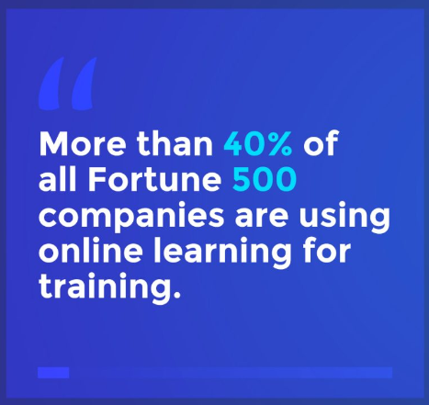

**Sources:**

<https://www.oxfordhomestudy.com/OHSC-Blog/what-is-elearning>

<https://e-student.org/advantages-of-e-learning/>

<https://archylearning.com/blog/the-8-most-important-benefits-of-elearning-for-students/>

<https://elmlearning.com/blog/10-reasons-elearning-works/>

<https://ddiy.co/online-learning-statistics/>