
Worksheet
Converting Binary to Decimal
Name: Grade: 7 ___________
Transistors:
- The computer’s microprocessor is a small component made up of millions of tiny electrical switches.
- Transistors can be only either On or Off
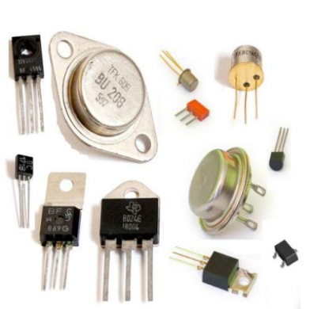
- A computer stores and processes data in a simple format because it only understands these two states On and Off
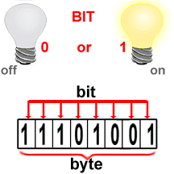
Binary system:
- The binary number system only uses zero and one to represent data.
Byte:
- Byte is the basic word that a computer uses.
- A byte is eight bits’ long
Measuring computer memory:
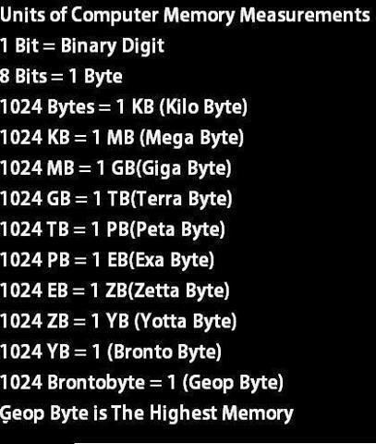
Write each binary number as a decimal number:
1- Binary = (10011) ₂  Decimal = | 2- Binary = (10000) ₂  Decimal =
3- Binary = (101011) ₂  Decimal = | 4- Binary = (1111) ₂  Decimal =
5- Binary = (110011) ₂  Decimal = | 6-Binary = (11000) ₂  Decimal =

