

**Worksheet**

**Converting Binary to Decimal**

Name: Markella Bursheh Grade: 7 c_____

**Transistors:**

* The computer’s microprocessor is a small component made up of millions of tiny electrical switches.
* Transistors can be only either **On or Off**

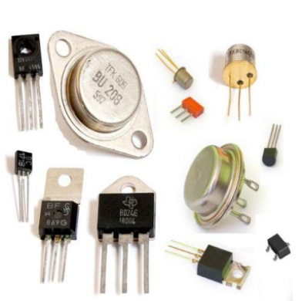

* A computer stores and processes data in a simple format because it only understands these two states On **and Off**

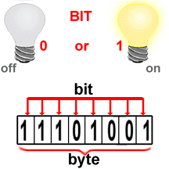

**Binary system:**

* The binary number system only uses zero and one to represent data.

**Byte:**

* Byte is the basic word that a computer uses.
* A byte is eight bits’ long

**Measuring computer memory:**

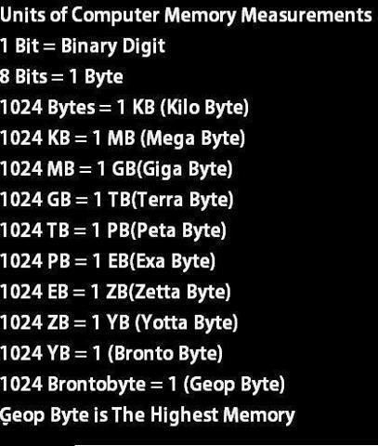

Write each binary number as a decimal number:

|  |  |  |  |  |  |  |  |  |  |  |  |  |  |  |  |  |  |  |  |  |  |  |  |  |  |  |  |  |  |  |  |  |  |  |  |  |
| --- | --- | --- | --- | --- | --- | --- | --- | --- | --- | --- | --- | --- | --- | --- | --- | --- | --- | --- | --- | --- | --- | --- | --- | --- | --- | --- | --- | --- | --- | --- | --- | --- | --- | --- | --- | --- |
| 1- Binary = (10011) 2  Decimal = 1+0+0+8+16= (25)10 | | | | | | | | | | | | | | | | | | | | | 2- Binary = (10000) 2  Decimal =1+0+0+0+0= (1)10 | | | | | | | | | | | | | | | |
| 1 0 0 1 1 | | | | | | | | | | | | | | | | | | | | | 1 0 0 0 0 | | | | | | | | | | | | | | | |
|  | 1 | | | 2 | | | | | 4 | | | 8 | | | 16 | | |  | | |  | 1 | | | 2 | | 4 | | | 8 | | 16 | | |  | |
| 3- Binary = (101011) 2  Decimal =1+0+4+0+16+32= (53)10 | | | | | | | | | | | | | | | | | | | | | 4- Binary = (1111) 2  Decimal =1+2+4+8= (15)10 | | | | | | | | | | | | | | | |
| 1 0 1 0 1 1 | | | | | | | | | | | | | | | | | | | | | 1 1 1 1 | | | | | | | | | | | | | | | |
|  | | 1 | | | 2 | | 4 | | | 8 | | | 16 | | | 32 | | |  | | 1 | | | 2 | | | | 4 | | | | | 8 | | | |
| 5- Binary = (110011) 2  Decimal =1+2+0+0+16+32= (51)10 | | | | | | | | | | | | | | | | | | | | | 6-Binary = (11000) 2  Decimal =1+2+0+0+0= (3)10 | | | | | | | | | | | | | | | |
| 1 1 0 0 1 1 | | | | | | | | | | | | | | | | | | | | | 1 1 0 0 0 | | | | | | | | | | | | | | | |
|  | | | 1 | | | 2 | | 4 | | | 8 | | | 16 | | | 32 | | |  |  | | 1 | | | 2 | | | 4 | | 8 | | | 16 | |  |