

**Worksheet**

**Converting Binary to Decimal**

Name: Grade: 7 ___________

**Transistors:**

* The computer’s microprocessor is a small component made up of millions of tiny electrical switches.
* Transistors can be only either **On or Off**

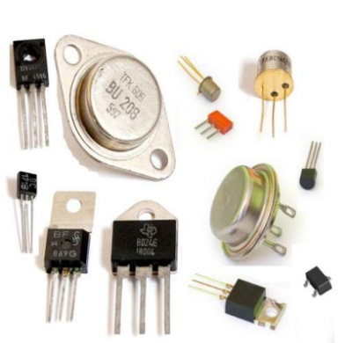

* A computer stores and processes data in a simple format because it only understands these two states On **and Off**

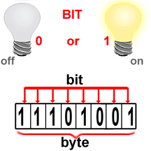

**Binary system:**

* The binary number system only uses zero and one to represent data.

**Byte:**

* Byte is the basic word that a computer uses.
* A byte is eight bits’ long

**Measuring computer memory:**

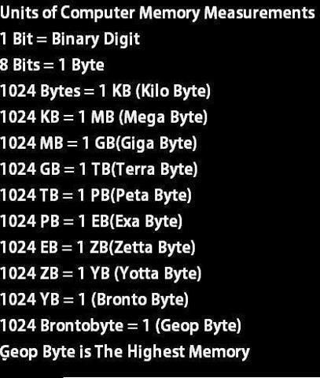

Write each binary number as a decimal number:

|  |  |  |  |  |  |  |  |  |  |  |  |  |  |  |  |  |  |  |  |  |  |
| --- | --- | --- | --- | --- | --- | --- | --- | --- | --- | --- | --- | --- | --- | --- | --- | --- | --- | --- | --- | --- | --- |
| **1- Binary = (10011) 2**  **Decimal = 32+0+0+4+2= (38) ¹⁰**   |  |  |  |  |  | | --- | --- | --- | --- | --- | | **1** | **0** | **0** | **1** | **1** | | **32** | **16** | **8** | **4** | **2** | | **2- Binary = (10000) 2**  **Decimal = 32+0+0+0+0= (32) ¹⁰**   |  |  |  |  |  | | --- | --- | --- | --- | --- | | **1** | **0** | **0** | **0** | **0** | | **32** | **16** | **8** | **4** | **2** | |
| **3- Binary = (101011) 2**  **Decimal = 64+0+16+0+4+2= (86) ¹⁰**   |  |  |  |  |  |  | | --- | --- | --- | --- | --- | --- | | **1** | **0** | **1** | **0** | **1** | **1** | | **64** | **32** | **16** | **8** | **4** | **2** | | **4- Binary = (1111) 2**  **Decimal = 16+8+4+2= (30) ¹⁰**   |  |  |  |  | | --- | --- | --- | --- | | **1** | **1** | **1** | **1** | | **16** | **8** | **4** | **2** | |
| **5- Binary = (110011) 2**  **Decimal = 64+32+0+0+4+2= (102) ¹⁰**   |  |  |  |  |  |  | | --- | --- | --- | --- | --- | --- | | **1** | **1** | **0** | **0** | **1** | **1** | | **64** | **32** | **16** | **8** | **4** | **2** | | **6-Binary = (11000) 2**  **Decimal = 32+16+0+0+0= (48) ¹⁰**   |  |  |  |  |  | | --- | --- | --- | --- | --- | | **1** | **1** | **0** | **0** | **0** | | **32** | **16** | **8** | **4** | **2** | |