The effect of changing the type pf solvent on the chromatography method measured by the distance travelled by the ink measured in cm.
Controlled variable | How will you keep this controlled? | How could it effect your result if not controlled?
- Volume of solvents | - Measuring cylinder | The colors will travel fast, and the colors will be light and they will go further.
The permanent markers I use are: Black, Blue and Red.
The solvents that I use are: Water, Rubbing Alcohol.
Photos for the Experiment Preparation
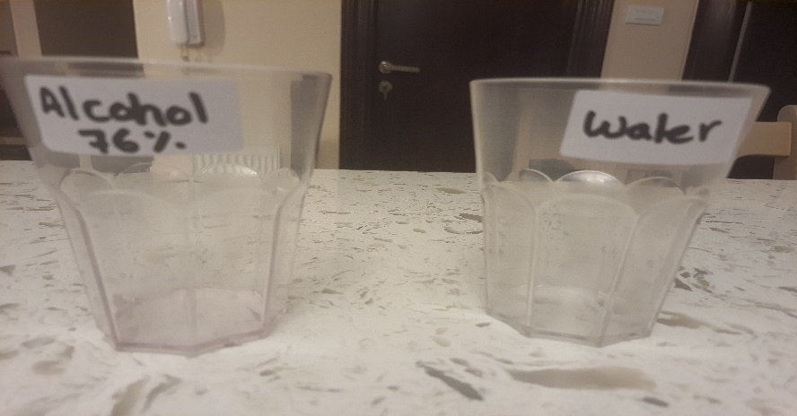 | 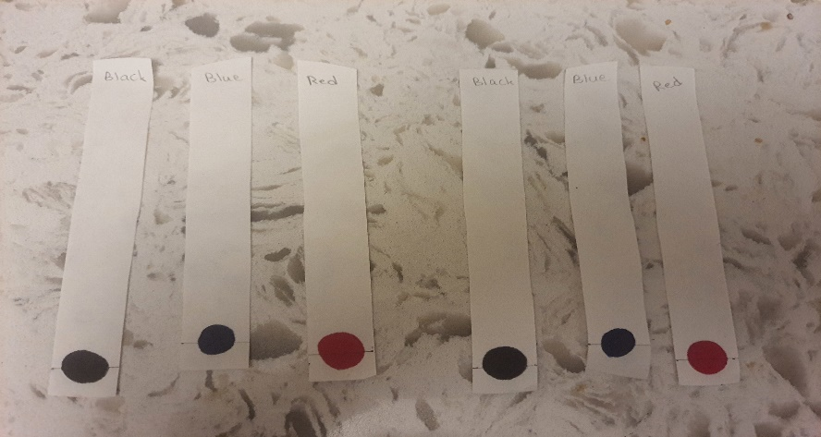 | 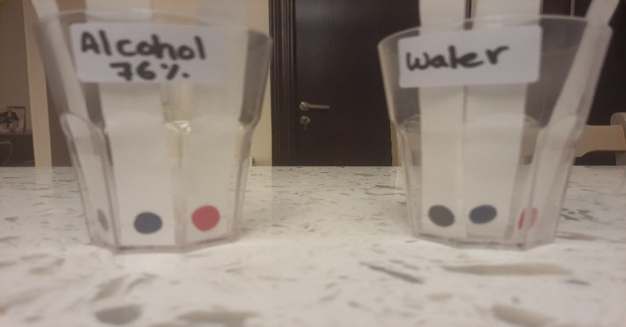
Results
Solvant | Color 1 | Colors appeared & distance travelled by each color/ cm | Color 2 | Colors appeared & distance travelled by each color/ cm | Color 3 | Colors appeared & distance travelled by each color/ cm
Water | Black | No other colors appeared.  0 cm | Red | Light Orange.  2.1 cm | Blue | No other colors appeared.  0 cm
Other Solvent Rubbing Alcohol | Black | Grey and light grey.  7 cm it travelled. | Red | Orange and Yellow.  7.8 it travelled. | Blue | 3.8 it travelled.

Photos shows the results
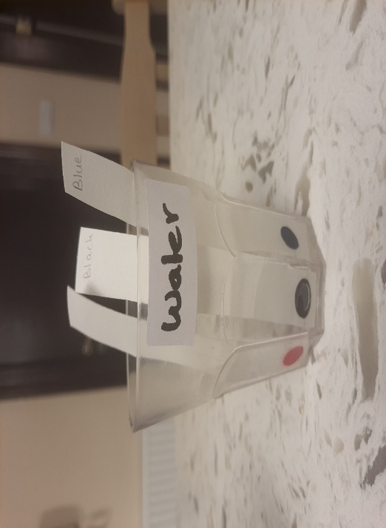 | 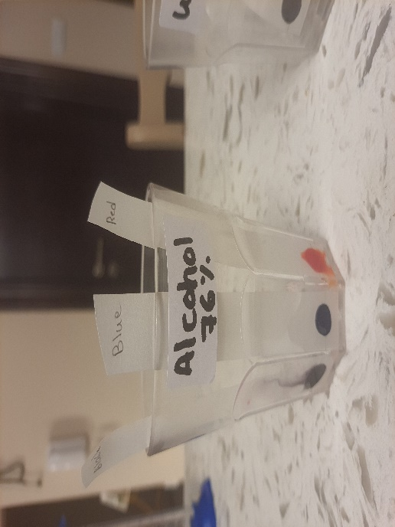 | 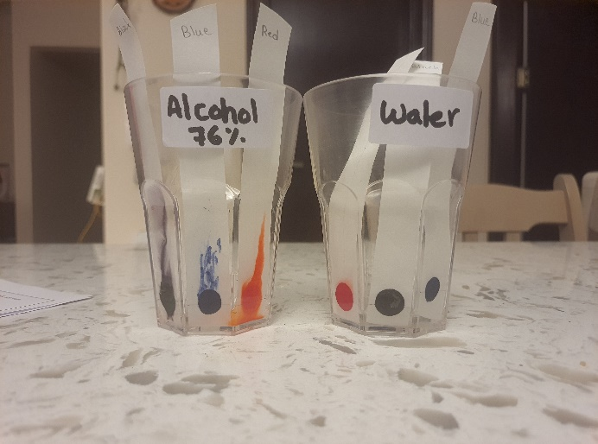 | 