

The National Orthodox School/ Shmessani
Name:Sanad Darwish Lab report ( 2 ) / Chromatography
Date: Grade .7 F

1) Writing a fully focused research question

What is the effect of changing the type of solvent on the chromatography method measured by the distance travelled by the ink measured in cm?

- Hypothesis:
In Paper chromatography the components of the solution separate and become visible as strips of color on the chromatography paper when they dissolve in the right solvent.

- Scientific explanation for hypothesis (This is the explanation to the previous hypothesis. Why do you think that your hypothesis is correct? Explain it in detail with reasons and causes.

Chromatography is a method that is used for separation of mixtures of chemical substances.
Chromatography is using a flow of solvent to cause the components of a mixture to migrate differently from a narrow starting point in a specific medium, in the case of this experiment, Paper towels/ filter papers.
Permanent markers are water-insoluble (that’s what makes them permanent), water is not going to get the job done. You can use other solvents like rubbing alcohol, nail polish remover, and vinegar to help us separate colors in permanent markers.

- Manipulating the variables: 1 marks

Controlled Variable | How will you keep this controlled? | How could it affect your results if not controlled?
Volume of the solvent  Type of the marker  Size and type of the paper used | Measuring cylinder  Use the same type  Use a ruler and use kitchen towels | ......more solvent, more will dissolve  Some marker might be more soluble than others so move further distance  different towels might have larger pores so more of the solvent will be absorbed.  Larger paper will absorb more of the solvent

- Materials and Method: 1 mark

paper towel strips/ Coffee filters
glass cups
Pencil
Ruler
Permanent markers Write the colors that you used (Use three colors one of them is black) black /red / green.
Water
Rubbing alcohol/ nail polish remover/ vinegar Write the solvent that you used. (vinegar)

- Method: What are the steps of the investigation?

- Cut paper towel/ coffee filters in strips.
- Draw a pencil line across the width of each paper strip, about one centimeter from the bottom end.
- Take the marker and a paper strip and draw a short line (about one centimeter) on the middle section of the pencil line. Your marker line should not touch the sides of your strip.
- Repeat step 3 for all the markers.
- Use a pencil to write the color of the marker you just used on the top end of the strip. Note: Do not use the colored marker or pen to write on the strips, as the color or ink will run during the test.
- Fill cups with a bit of the solvent you are testing out: START WITH WATER. add water to the glass until the level just reaches the bottom end of the paper strip.
- Hang the paper strip over the edge of the glass so that the paper towel/ coffee filter touches the liquid, but the line is above the liquid.
- Watch as the water rises up the strips.
- Record your observation. (What happens to the colored lines on the strips? Does the color run up as well? Do you see any color separation?
- Repeat steps 1-9 using another solvent. Write the solvent that you used (vinegar)

Safety precautions
Don’t use rubbing alcohol/ nail polish remover near flames.
Wash hands after using any chemical.

- Results 3 marks

- Data

Solvent | Color  1 | Colors appeared& distance travelled by each color/ cm | Color  2 | Colors appeared &  distance travelled by each color/cm | Color  3 | Colors appeared&  distance travelled by each color/cm
Water | blue | It was only blue  And it travelled  6.4 cm | green | It turned into  Green and  Blue with shades of yellow and it travelled 7.4 cm | purple | It turned into purple and pink with shades of blue and travelled 6.5 cm
Other solvent nail polish remover  (aceton) | blue | It travelled 3 cm and the blue dissolved completely and yellow remained | green | The green dissolved completely, producing brick red, blue and purple. had shades of yellow and orange. It travelled 4 cm | purple | The purple dissolved completely, producing pink, orange with shades of yellow.it travelled 4.3 cm

Add a photo to show the results
Results with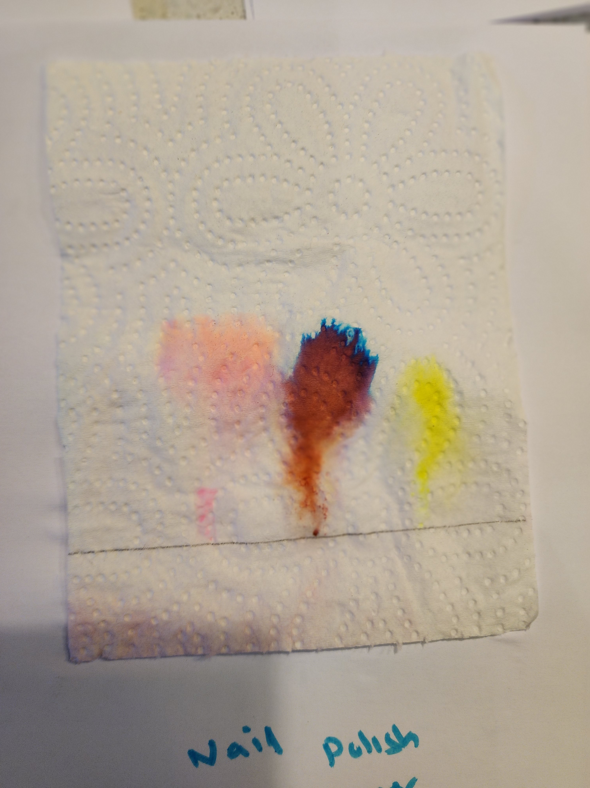 other solvent
Resul 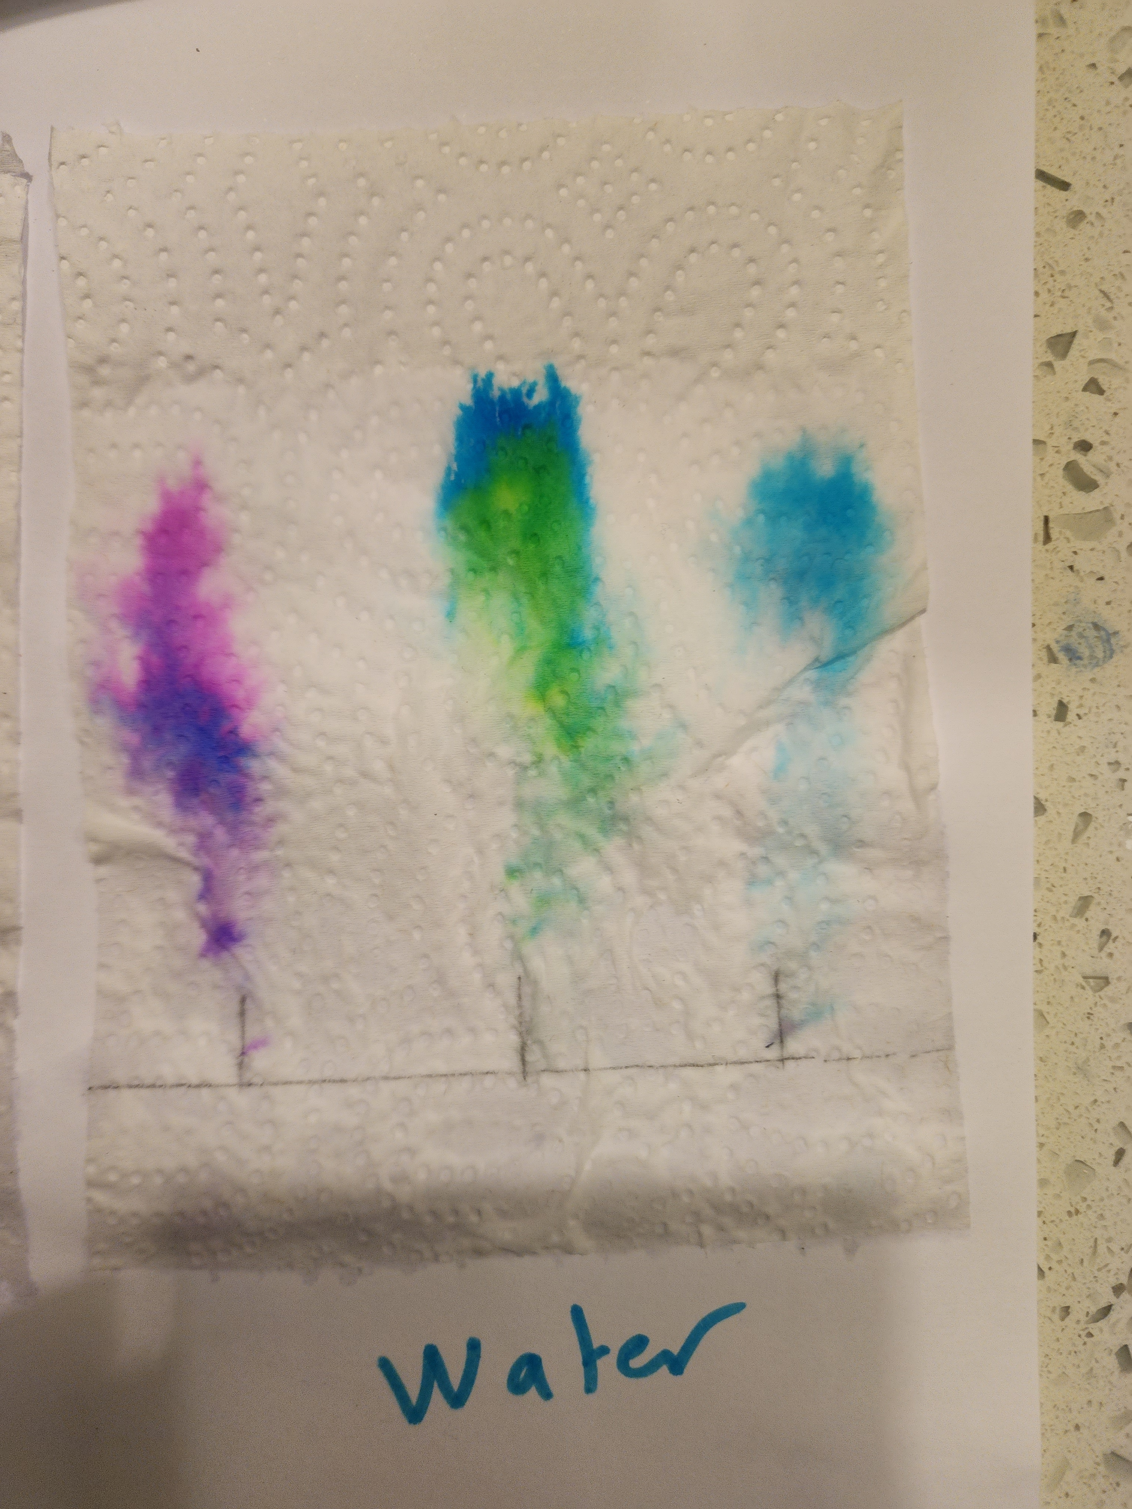t s with water

