

**The National Orthodox School/ Shmessani**

**Name: ........................... Lab report ( 2 ) / Chromatography**

**Date: Grade ...............**

**1) Writing a fully focused research question**

What is the effect of changing the type of solvent on the chromatography method measured by the distance travelled by the ink measured in cm?

1. **Hypothesis:**

In Paper chromatography the components of the solution separate and become visible as strips of color on the chromatography paper when they dissolve in the right solvent.

1. **Scientific explanation for hypothesis *(This is the explanation to the previous hypothesis. Why do you think that your hypothesis is correct? Explain it in detail with reasons and causes.***

Chromatography is a method that is used for separation of mixtures of chemical substances.

Chromatography is using a flow of solvent to cause the components of a mixture to migrate differently from a narrow starting point in a specific medium, in the case of this experiment, Paper towels/ filter papers.

**Permanent markers** are water-insoluble (that’s what makes them permanent), water is not going to get the job done. You can use other solvents like rubbing alcohol, nail polish remover, and vinegar to help us separate colors in permanent markers.

1. **Manipulating the variables: 1 marks**

|  |  |  |
| --- | --- | --- |
| **Controlled Variable** | **How will you keep this controlled?** | **How could it affect your results if not controlled?** |
| Time the paper is in the solvent | stopwatch | If you put one longer than the other it will dissolve more so the are so we wont have accurate results |

1. **Materials and Method: 1 mark**

paper towel strips/ Coffee filters

glass cups

Pencil

Ruler

**Permanent markers** Write the colors that you used (Use three colors one of them is black)

Black,green,purple

Water

Rubbing alcohol/ nail polish remover/ vinegar  Write the solvent that you used ...............

Rubbing alcohol

* **Method: What are the steps of the investigation?**

1. Cut paper towel/ coffee filters in strips.
2. Draw a pencil line across the width of each paper strip, about one centimeter from the bottom end.
3. Take the marker and a paper strip and draw a short line (about one centimeter) on the middle section of the pencil line. Your marker line should not touch the sides of your strip.
4. Repeat step 3 for all the markers.
5. Use a pencil to write the color of the marker you just used on the top end of the strip. Note: **Do not use the colored marker or pen to write on the strips, as the color or ink will run during the test.**
6. Fill cups with a bit of the solvent you are testing out: **START WITH WATER**. add water to the glass until the level just reaches the bottom end of the paper strip.
7. Hang the paper strip over the edge of the glass so that the paper towel/ coffee filter touches the liquid, but the line is above the liquid.
8. Watch as the water rises up the strips.
9. Record your observation. (What happens to the colored lines on the strips? Does the color run up as well? Do you see any color separation?
10. Repeat steps 1-9 using **another solvent**. **Write the solvent that you used ....rubbing alcohol/ ethanol**

**Safety precautions**

Don’t use rubbing alcohol/ nail polish remover near flames.

Wash hands after using any chemical.

1. **Results 3 marks**

* **Data**

|  |  |  |  |  |  |  |
| --- | --- | --- | --- | --- | --- | --- |
| **Solvent** | **Color**  **1** | **Colors appeared& distance travelled by each color/ cm** | **Color**  **2** | **Colors appeared &**  **distance travelled by each color/cm** | **Color**  **3** | **Colors appeared&**  **distance travelled by each color/cm** |
| **Water** | Green | 4cm  Light green anda bit of yellow | purple | 3.7  Lighter shades of purple | black | 2.3cm  Dark purple |
| Other solvent ............... | green | Had not moved  Because the color aren’t soluble | purple | Had not moved  Because the color aren’t soluble | black | Had not moved  Because the color aren’t soluble |

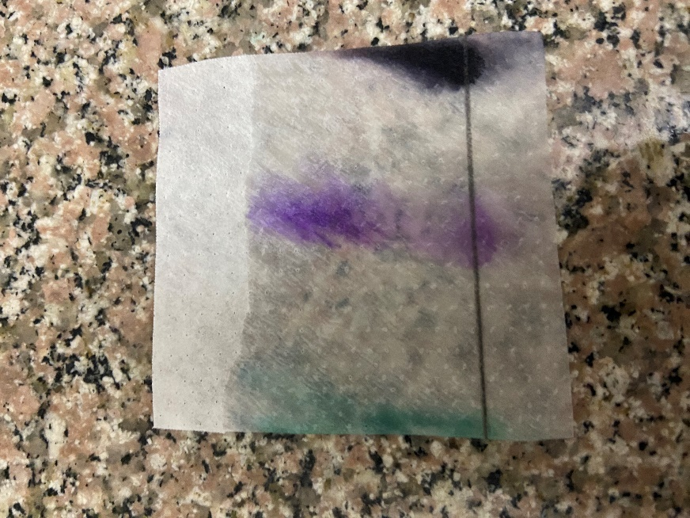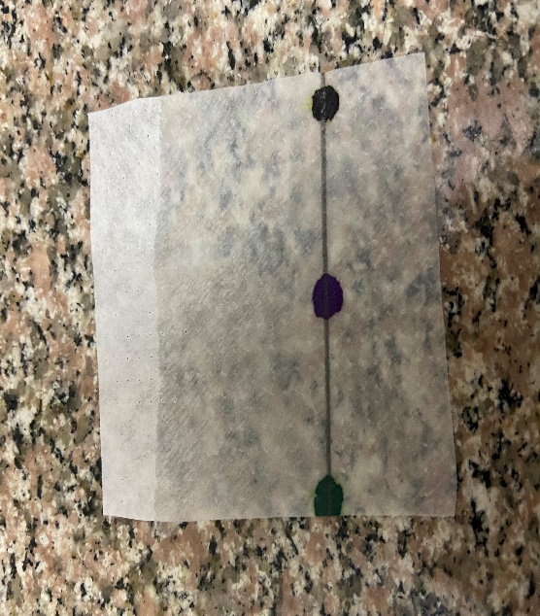**Add a photo to show the results**

Results with other solvent

Results with water

|  |  |
| --- | --- |
|  |  |