

**The National Orthodox School/ Shmessani**

**Name: ........................... Lab report ( 2 ) / Chromatography**

**Date: Grade ...............**

**1) Writing a fully focused research question**

What is the effect of changing the type of solvent on the chromatography method measured by the distance traveled by the ink measured in cm?

1. **Hypothesis:**

In Paper chromatography the components of the solution separate and become visible as strips of color on the chromatography paper when they dissolve in the right solvent.

1. **Scientific explanation for hypothesis**

Chromatography is a method that is used for the separation of mixtures of chemical substances.

Chromatography is using a flow of solvent to cause the components of a mixture to migrate differently from a narrow starting point in a specific medium, in the case of this experiment, Paper towels/ filter papers.

**Permanent markers** are water-insoluble (that’s what makes them permanent), water is not going to get the job done. You can use other solvents like rubbing alcohol, nail polish remover, and vinegar to help us separate colors in permanent markers.

1. **Manipulating the variables: 1 marks**

|  |  |  |
| --- | --- | --- |
| **Controlled Variable** | **How will you keep this controlled?** | **How could it affect your results if not controlled?** |
| The same type of filtration paper | By using the same type of filtration paper | It affects how far the solvent gets in the paper |
| Same room temperature | By doing the experiments in the same place at the same time | It affects the movement of the solvent and solute particles |

1. **Materials and Method: 1 mark**

paper towel strips/ Coffee filters

glass cups

Pencil

Ruler

**Black, blue and green permanent markers**

Water

**Rubbing alcohol**

* **Method: What are the steps of the investigation?**

1. Cut paper towel/ coffee filters into strips.
2. Draw a pencil line across the width of each paper strip, about one centimeter from the bottom end.
3. Take the marker and a paper strip and draw a short line (about one centimeter) on the middle section of the pencil line. Your marker line should not touch the sides of your strip.
4. Repeat step 3 for all the markers.
5. Use a pencil to write the color of the marker you just used on the top end of the strip. Note: **Do not use the colored marker or pen to write on the strips, as the color or ink will run during the test.**
6. Fill cups with a bit of the solvent you are testing out: **START WITH WATER**. add water to the glass until the level just reaches the bottom end of the paper strip.
7. Hang the paper strip over the edge of the glass so that the paper towel/ coffee filter touches the liquid, but the line is above the liquid.
8. Watch as the water rises up the strips.
9. Record your observation. (What happens to the colored lines on the strips? Does the color run up as well? Do you see any color separation?
10. Repeat steps 1-9 using **another solvent**. **Write the solvent that you used ...................**

**Safety precautions**

Don’t use rubbing alcohol/ nail polish remover near flames.

Wash hands after using any chemical.

1. **Results 3 marks**

* **Data**

|  |  |  |  |  |  |  |
| --- | --- | --- | --- | --- | --- | --- |
| **Solvent** | **Color**  **1** | **Colors appeared& distance travelled by each color/ cm** | **Color**  **2** | **Colors appeared &**  **distance travelled by each color/cm** | **Color**  **3** | **Colors appeared&**  **distance travelled by each color/cm** |
| **Water** | blue | Blue and 0.8cm | green | Green and 0.1 cm | Black | Black 0.1 |
| Other solvent  Rubbing alcohol | blue | Blue and 3.8 cm | green | Blue and yellow and  2.7 cm | black | Black and  3 cm |

**Add a photo to show the results**

Results with water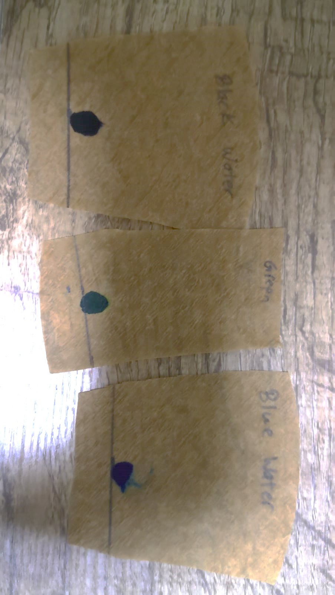

Results with other solvent

    
    
    