Reflective Writing

I learned that I am not really good in team work because I feel like I would like to work individually rather than with a partner because I am confident that I work more efficiently as an individual because I can use my creativity and adapt it into the project.

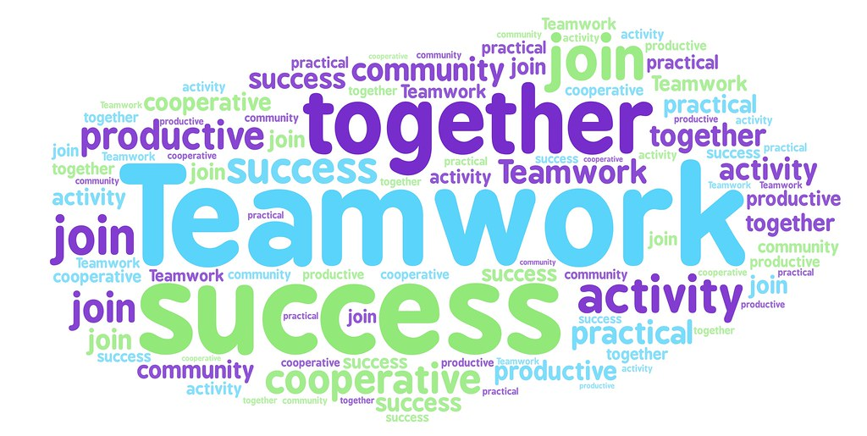One of the problems we faced was that we couldn’t line up our schedule well. But we overcame this problem by finding a perfect time where both of us were available to work on the project together. Additionally, my partner contributed well to our team by being very supportive and encouraging. He also was very creative and came up with spectacular ideas that helped make our project great.