**+++++++++++++++++++++++++++++++++++++++++++++++++++++++++++++++++++++++++++The National Orthodox School /Shmaisani**

**Subject: Physics Mark: _____/___**

**Name: Title: Hooke’s Law Lab Report 9 IB (G)**

1. Research Question:

What is the effect of changing the mass (IV ) on the extension of the spring (DV) measured by using a ruler in cm?

1. **Hypothesis:** Outline a hypothesis to predict the outcome of the experiment and

explain it using logical scientific *reasoning (what do you think is going to happen*

If the mass increases

(State the IV) (increase, decrease, or change)

then the extension of the spring will increase

(State the DV) (increase, decrease, stay the same, or change)

**Scientific explanation for hypothesis (**This is the explanation to the previous hypothesis. Why do you think that your hypothesis is correct? Explain it in detail with reasons and causes. You may also find research at this point if allowed).

Because:

Springs have an elastic behavior as it returns to its original length when any deforming forces have been removed as long as we do not cross its elastic limit (the point of no return). When attaching more weight to the spring, the spring will extend due to the pull of gravity on it. The weight of an object is calculated by the rule W=mg, where g is the gravity on earth and around $10 m/s^{2}$

1. **Manipulating the variables:**

|  |  |  |
| --- | --- | --- |
| **Controlled Variable** | **How will you keep this controlled? Stating the values and the equipment that you will be using** | **How could it affect your results if not controlled?** |
| spring | Using the same spring | Different extension values due to different spring constants |
| reference point | From the same point | Different results |

1. **Materials and Method**:

State your materials [ number needed + units] (Be descriptive, example: 10cm3 graduated cylinder)

* 1 spring
* 1 stand and clamp
* 1 ruler
* 1 metal hook
* 5 100g metal weights

**Method:**

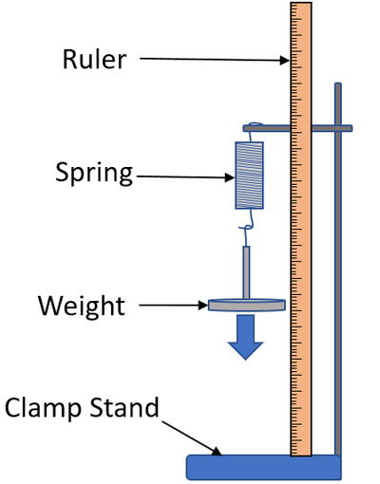

1. Assemble the apparatus and allow the spring to hang down.
2. Measure the starting position at the bottom end of the spring on the ruler.
3. Take the first mass, which consists of the base plate and hang it on the spring.
4. Measure the new position of the bottom end of the spring on the ruler. The difference in the readings is the extension of the spring.
5. Add masses one by one to the first one. Add the masses carefully so that the spring stretches slowly.
6. You should then reverse the experiment to see what happens as the masses are removed.
7. Calculate the extension and write it in table 1 and plot a graph of the force against extension in graph 1.
8. **Safety, Ethical and Environmental issues**

* **Care should be taken when placing the masses not to drop them on your feet.**
* **Eye protection**

1. **Results**

**Table 1 Raw Data:**

|  |  |
| --- | --- |
| **Mass (g)** | **Length of Spring (cm)** |
| **0** | **5.5** |
| **100** | **8.5** |
| **200** | **10.5** |
| **300** | **15** |
| **400** | **17.5** |
| **500** | **22** |
| **600** | **25.5** |

|  |  |  |  |  |  |  |  |  |  |  |  |  |  |  |  |  |  |
| --- | --- | --- | --- | --- | --- | --- | --- | --- | --- | --- | --- | --- | --- | --- | --- | --- | --- |
|  | **Table 2 Processed Data:**   |  |  | | --- | --- | | **Force (N)** | **Extension of Spring (cm**) | | **0** | **0** | | **1** | **3** | | **2** | **5** | | **3** | **9.5** | | **4** | **11.5** | | **5** | **16.5** | | **6** | **20** |  1. **Graphing your results sent it alone because I cant drew here**   Graph 1: Raw Data    Graph 2: Processed Data       1. **Describe your graph**  * Describe the trend in the graph without explanation * Discuss any relationship between independent and dependent variable * As the mass increases the tension increases * extension of an elastic object is directly proportional to the force applied to it. If no force is applied, there is no extension the graph of force against extension is a straight line through the origin, which shows a linear relationship.  1. **Conclusion and evaluation:** 2. Restating the purpose (hypothesis)   As the mass increases the extension of the spring will increase   1. Interpret your data and describe a conclusion based on your results.  Determine whether the original hypothesis was supported or rejected by the investigation? State numbers from the graph that support your views   It was supported because when we putted the mass of 100 g the extension changed from 0 to 5.5 so as the mass increase the extension will increases  c) State the errors that might occur during this experiment. |

The main cause of error in this experiment is reading the stretched length of the spring. The meter rule scale should be read at eye level directly opposite the pointer.