**Zaid Bakeer 7E**

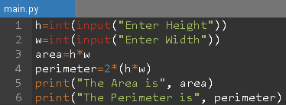**Question 1: Evidence 1**

h=int(input("Enter Height"))

w=int(input("Enter Width"))

area=h*w

perimeter=2*(h*w)

print("The Area is", area)

print("The Perimeter is", perimeter)

**Question2: Evidence 2**

**name=input("Enter Your Name")**

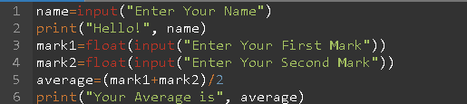**print("Hello!", name)**

**mark1=float(input("Enter Your First Mark"))**

**mark2=float(input("Enter Your Second Mark"))**

**average=(mark1+mark2)/2**

**print("Your Average is", average)**

**Question 3: Evidence 3**

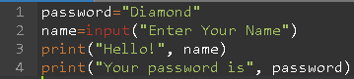**password="Diamond"**

**name=input("Enter Your Name")**

**print("Hello!", name)**

**print("Your password is", password**