**Question 1: Evidence 1**

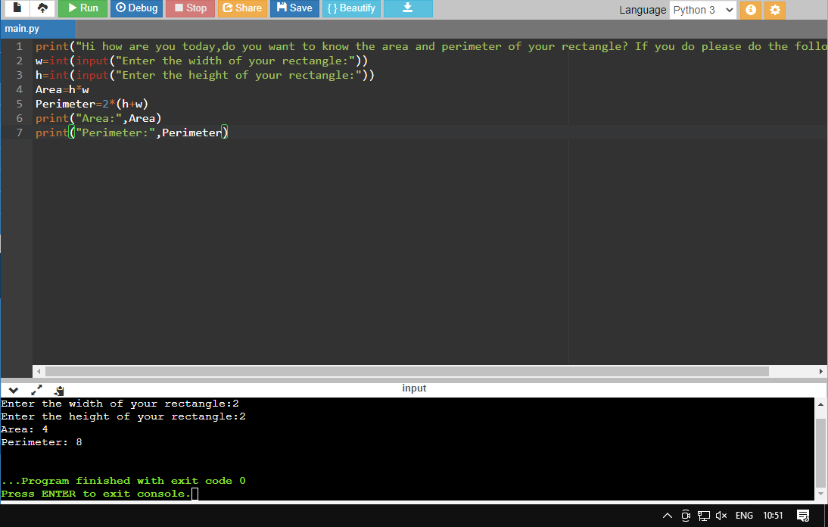

**Question2: Evidence 2**

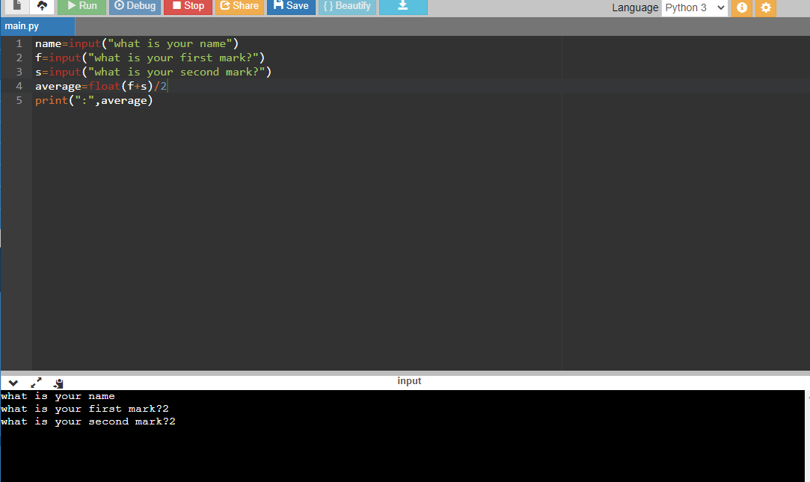

**Question 3: Evidence 3**