1. 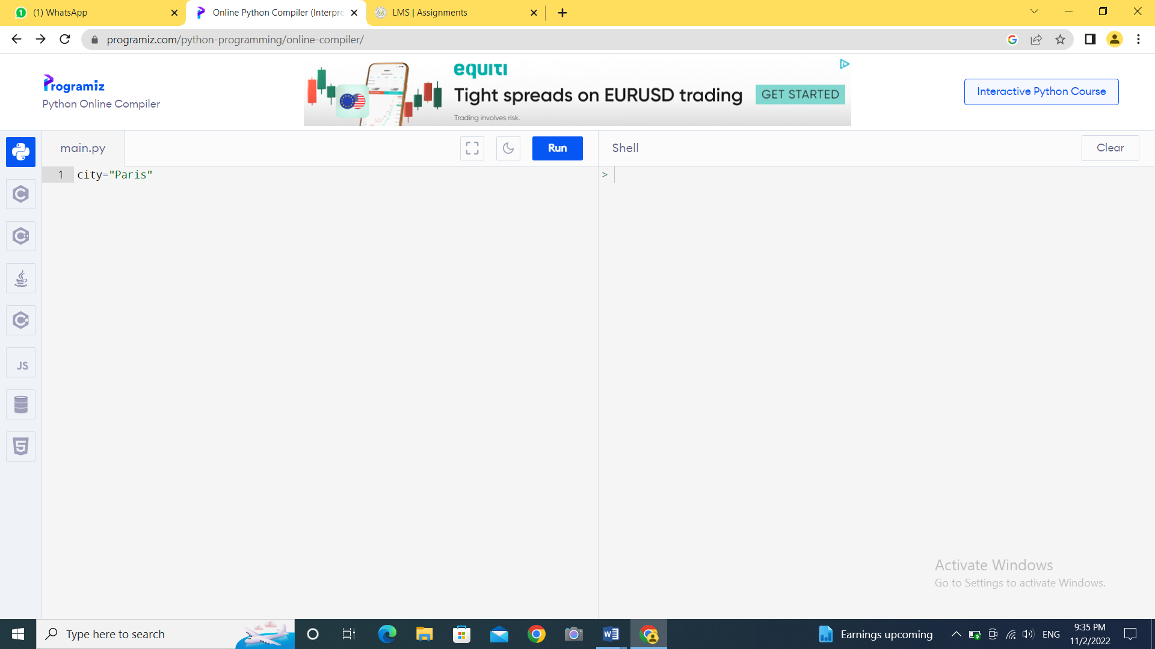
2. 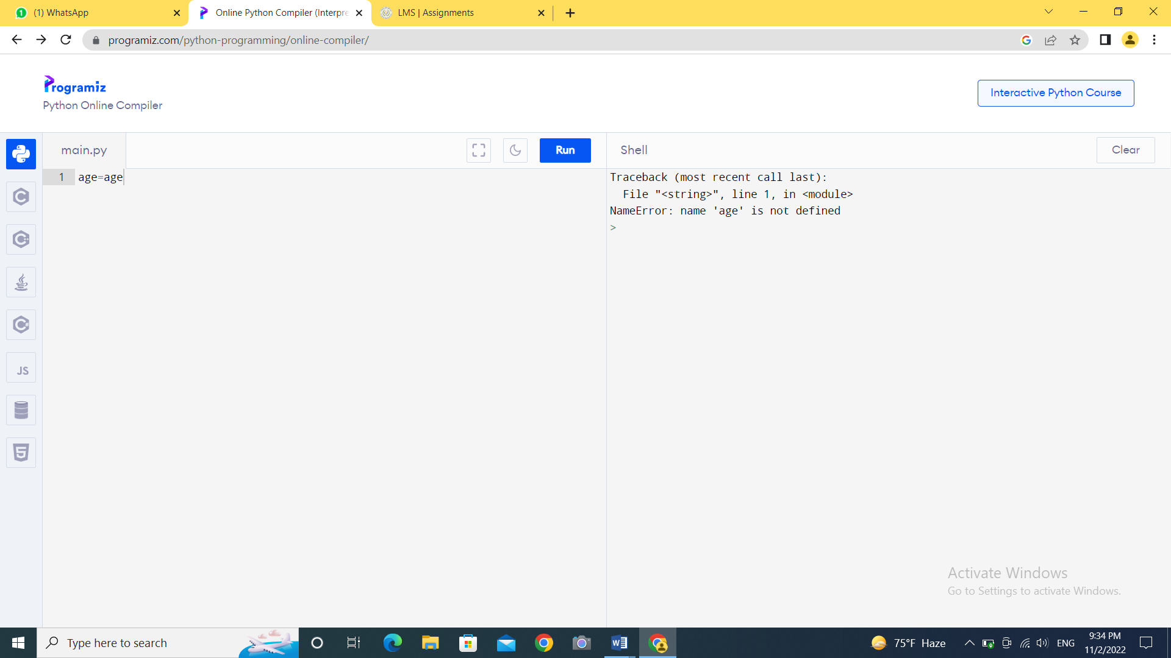
3. 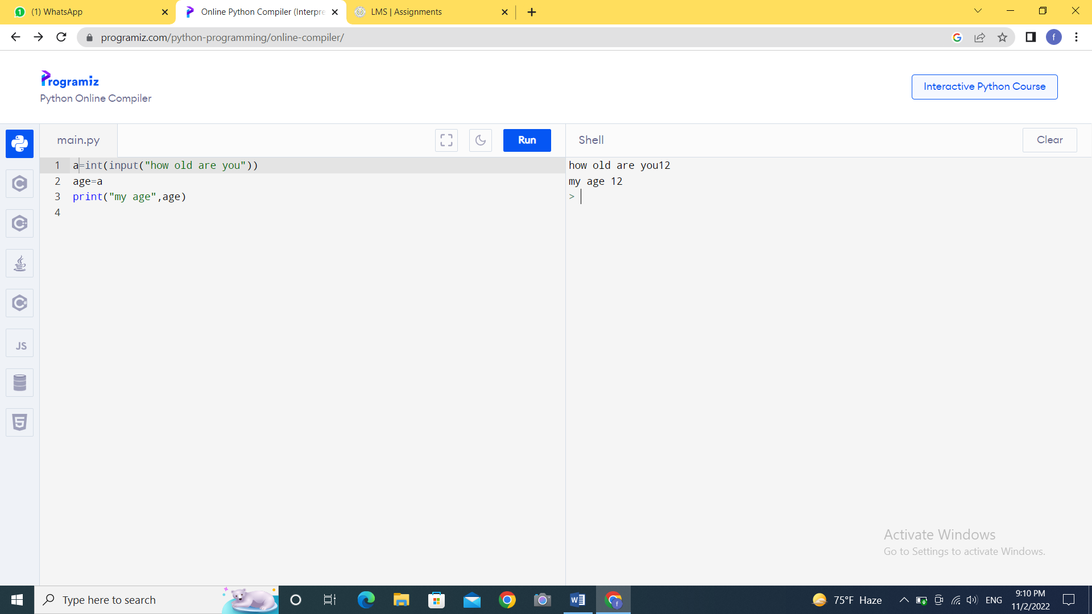
4. If you make a mistake, the Python Shell displays an error message. An error message tells you that there is a mistake. The error message helps you to find the error. Then you can type the command again, but without the error.