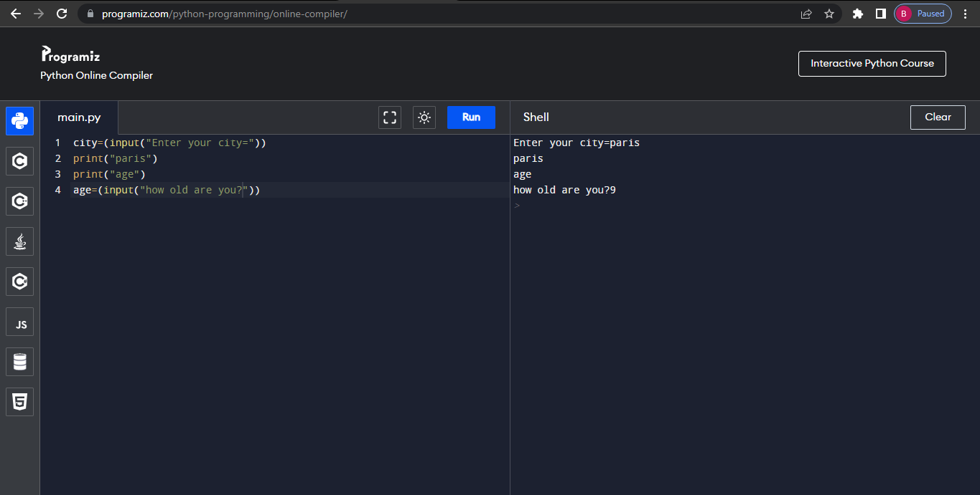

Q4) It helps you to fix your mistakes in coding.