1. 



2.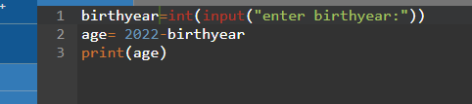



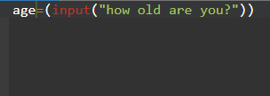

3.

4. Error messages help you to be a good programmer by helping you find the error, so you can type the command again, but without the error.

