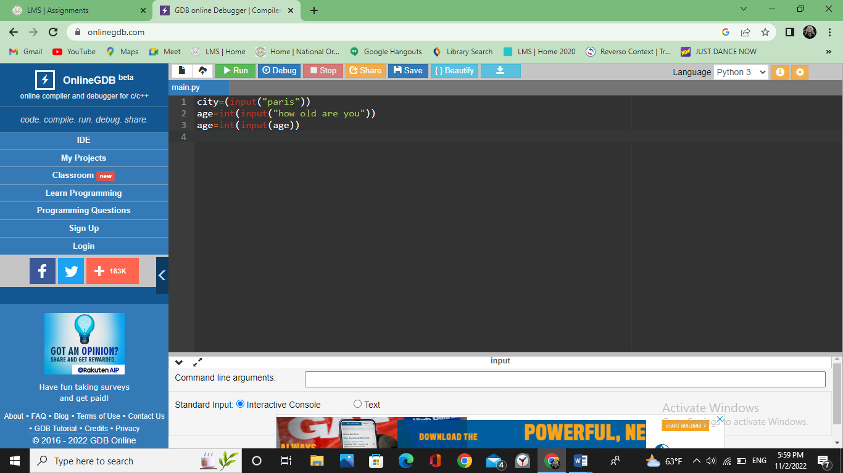Q1, 2, 3

Q4. They can tell you that the coding you did has something wrong in it so you can fix it and have a better coding.