**My Answers**

**1.** **Phyllidia** invites lucy to Corfu.

**2.** **Sir Julian Gale** came after the accident.

**3.** **Max Gale** tells lucy to go away from the castello.

**4.** **Godfrey Manning** was taking photos.

**5.** **Spiro** had an accident and drowned.

**6. Godfrey Manning** was the last person.

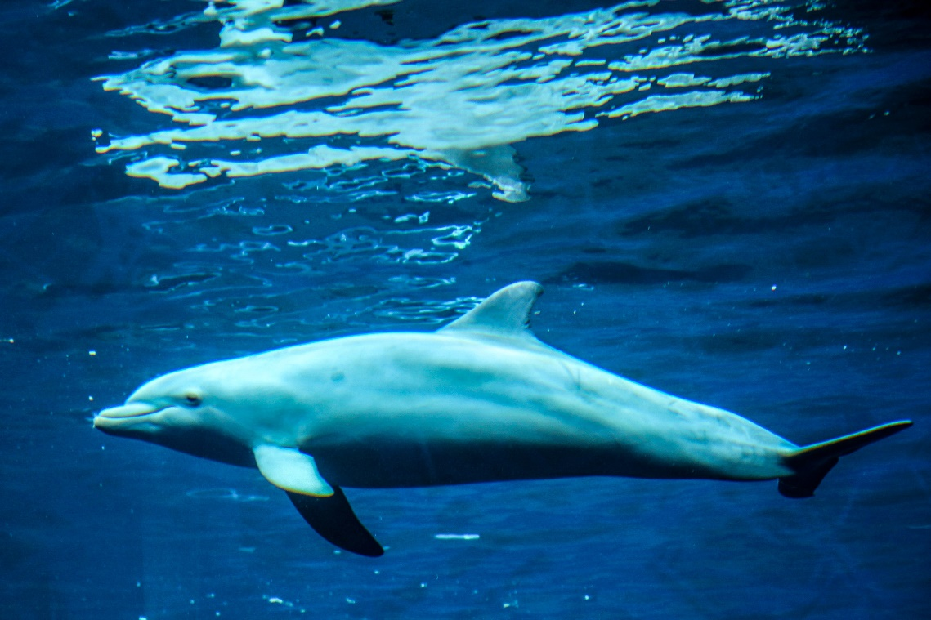

**By: Zaid Bakeer 7E**