Page 69 Homework

**Question 1:** “Oak”

**Question 2:** del trees [2]

**Question 3:** trees[1]="eucalyptus"

**Question 4:** It caused an error because there is no command (6) in the whole command.

Question 2:

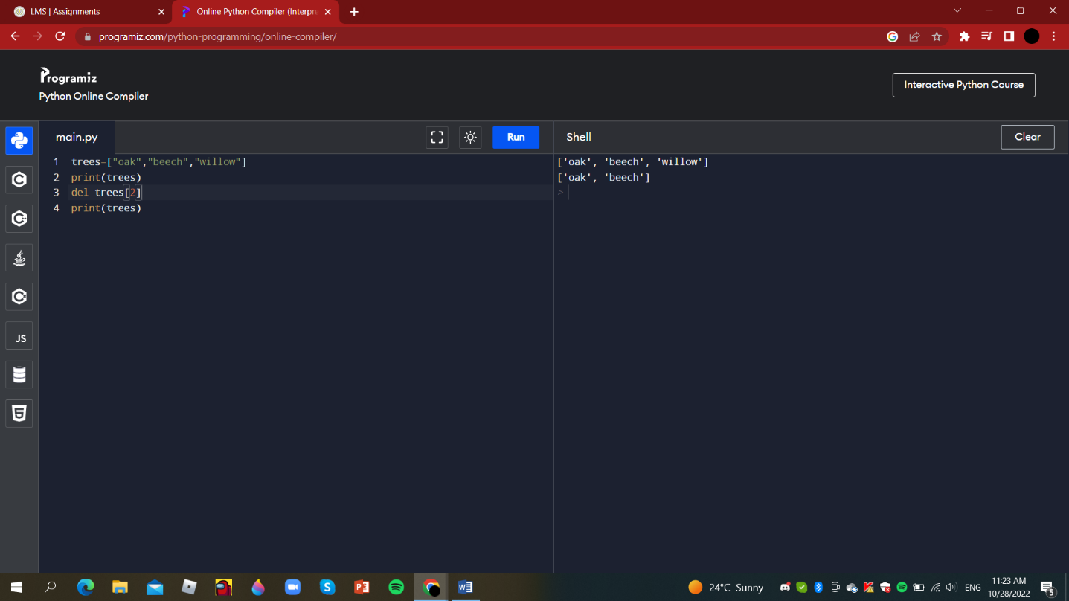

Question 3:

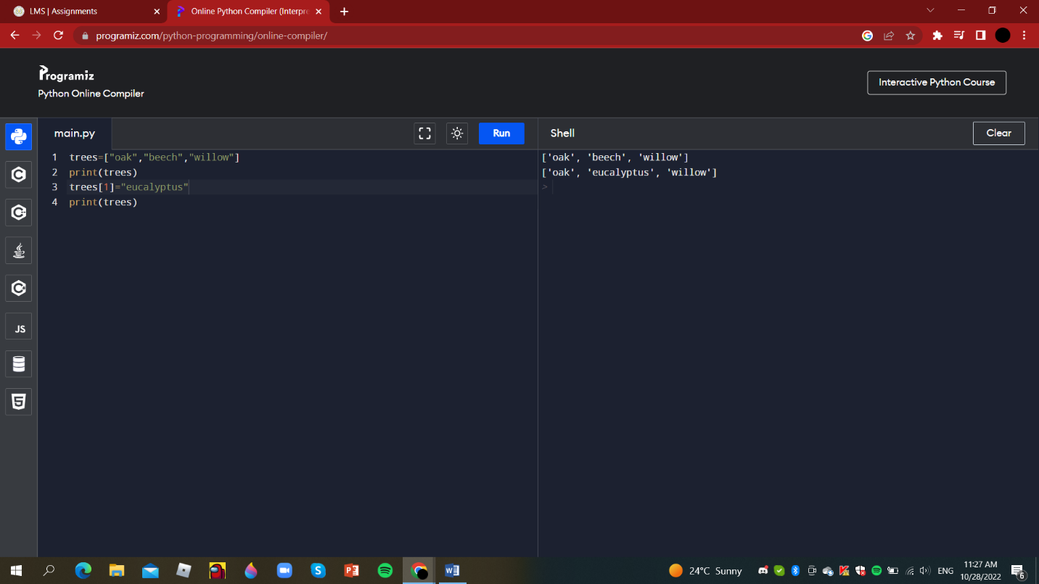

Question 4:

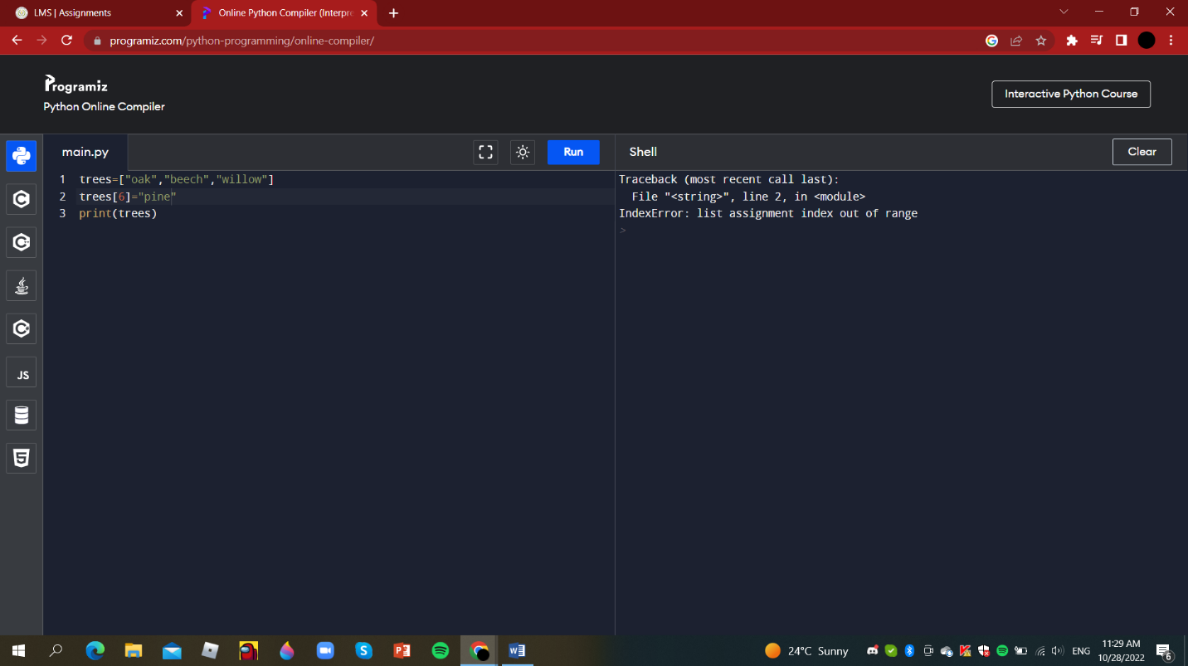

Done ☺