For this project we used two different types of research methods we did a survey and sent it to people diagnosed with diabetes we also did an interview with a nutritionist, and we also checked all the information we got from trusted websites.

Here are the links we used to make sure about all the information we got.

https://www.mayoclinic.org/diseases-conditions/type-2-diabetes/in-depth/diabetes-prevention/art-20047639

https://www.cdc.gov/diabetes/basics/symptoms.html

https://www.diabetes.org.uk/diabetes-the-basics/diabetes-treatments

For the survey these are all the responses we got from diabetes patient

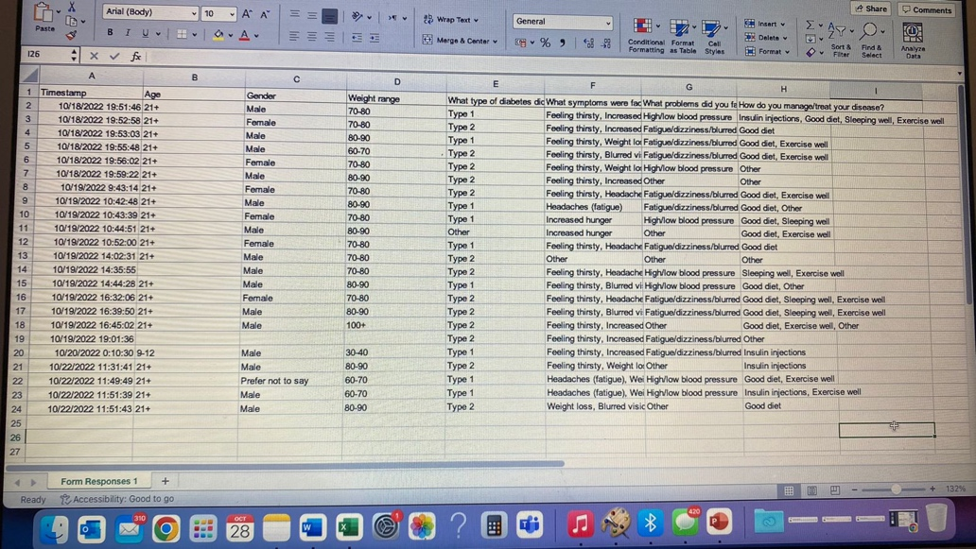

Meeting 1: Tamara: she worked well, and she did all the things she needed to she also kept track on what we still need to do.

Tia: she worked very well, and she also helped finalize everything before submitting.

Diala: she did what was needed to, and she helped take notes during the interview.

Naya: in the first meeting she worked good and she helped but she was on her phone most of the time but still worked well.

Meeting 2: everyone worked well and did as needed.

