Survey answers

About survey:

we got 22 responses in total

we have 4 main questions

we got answers from outside the school and people in the school as well

1. What was your name?

this was an optional question and 14/22 answered

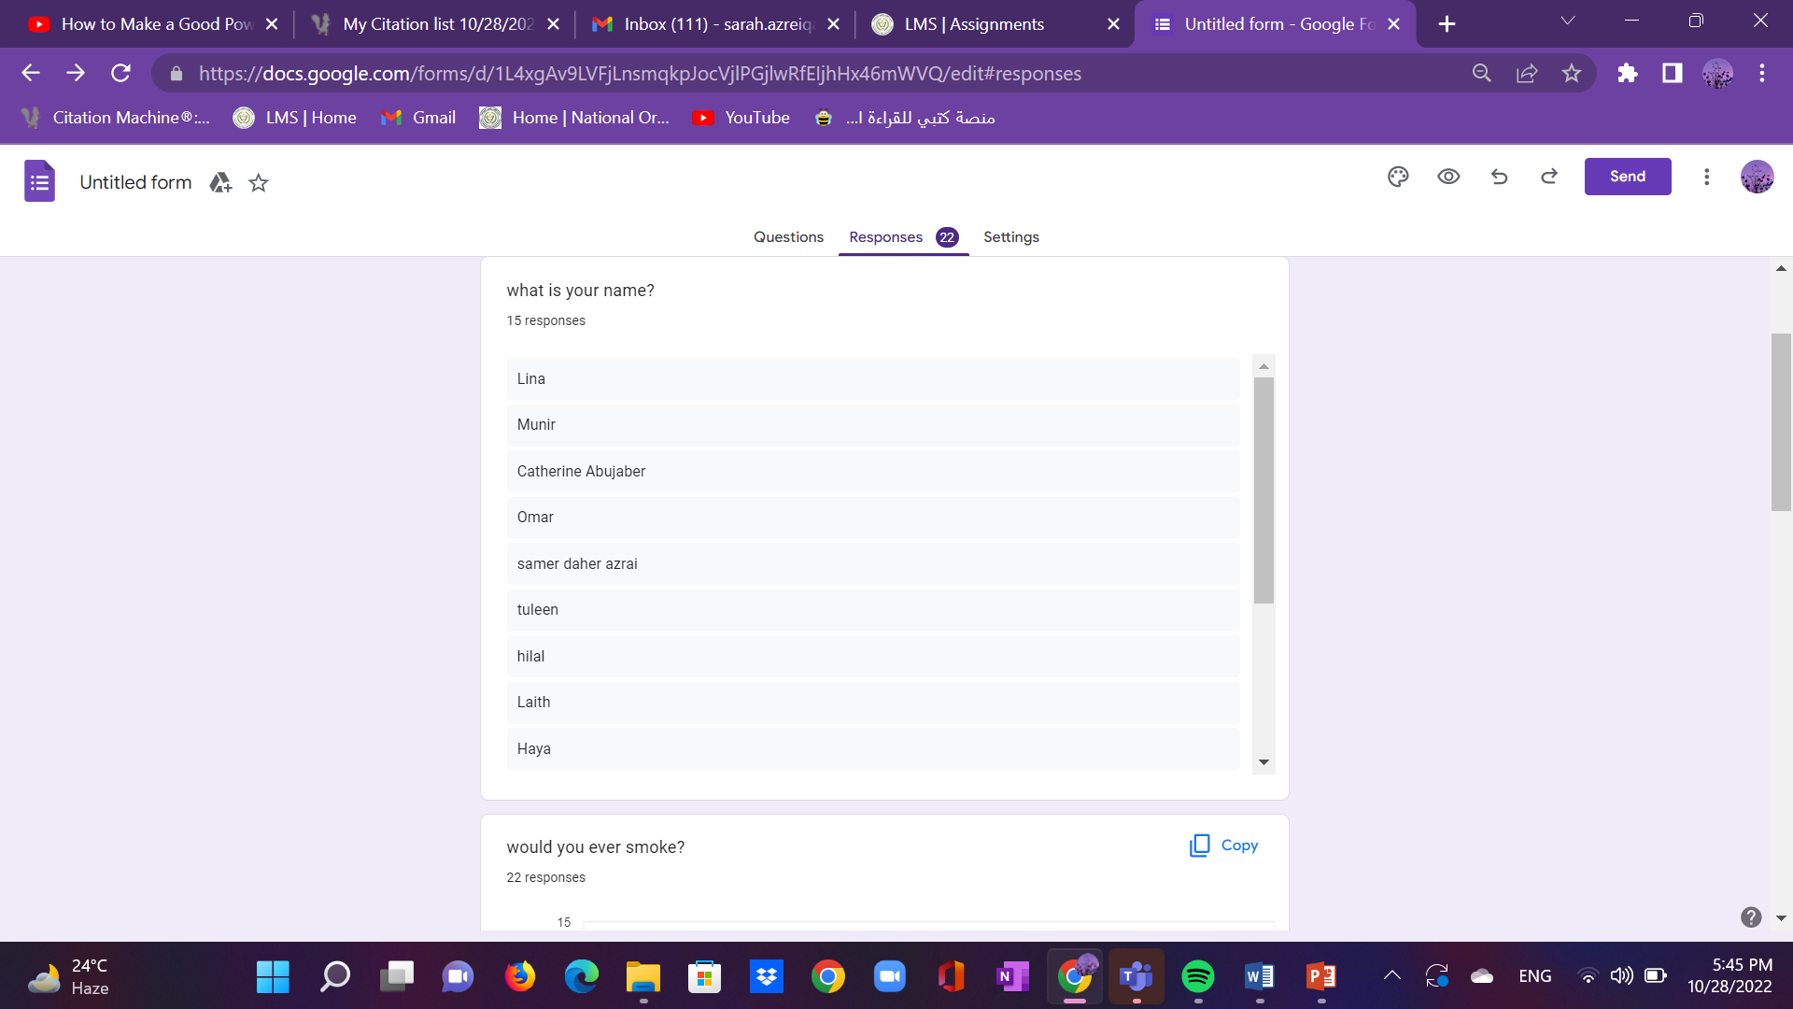



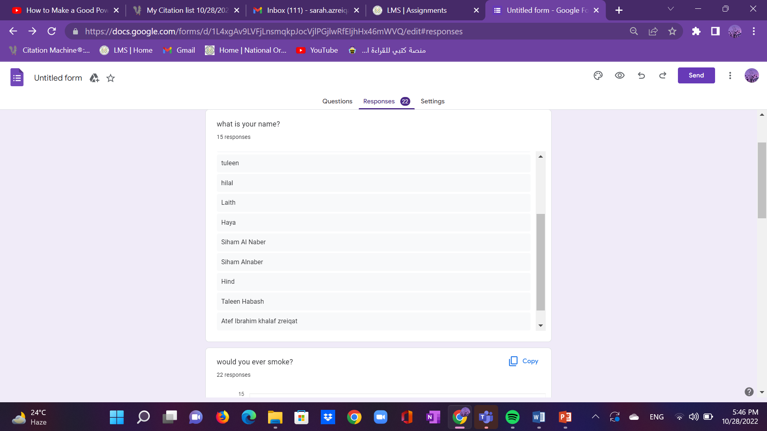

Q2. Would you ever smoke?

We got 22 responses

There were different answers regarding this most people said no, some people said yes, and a few people said they might smoke in future times

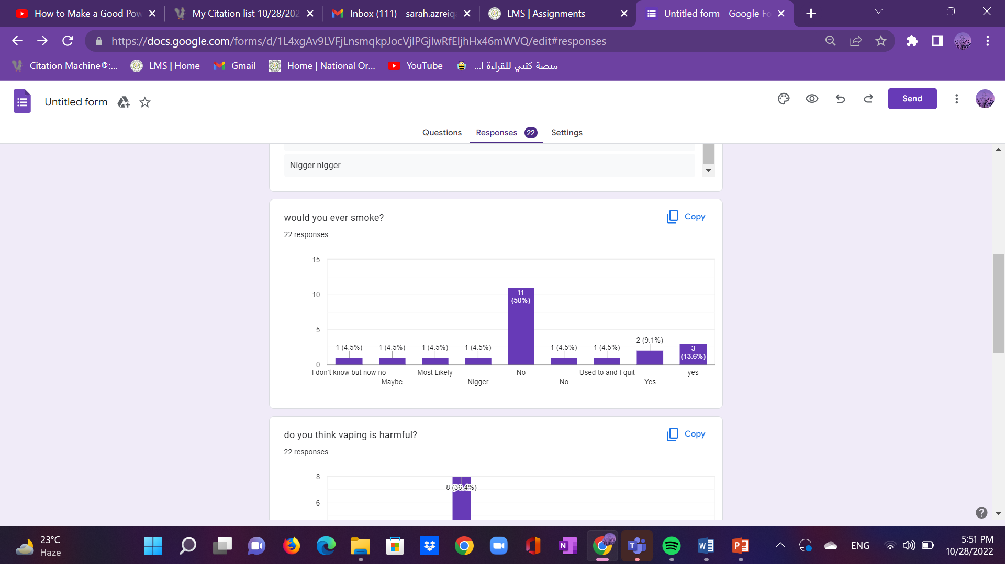

Q3. Do you think smoking is harmful ?

We got 22 responses

Most people mostly answered the same thing regarding to this question which is yes

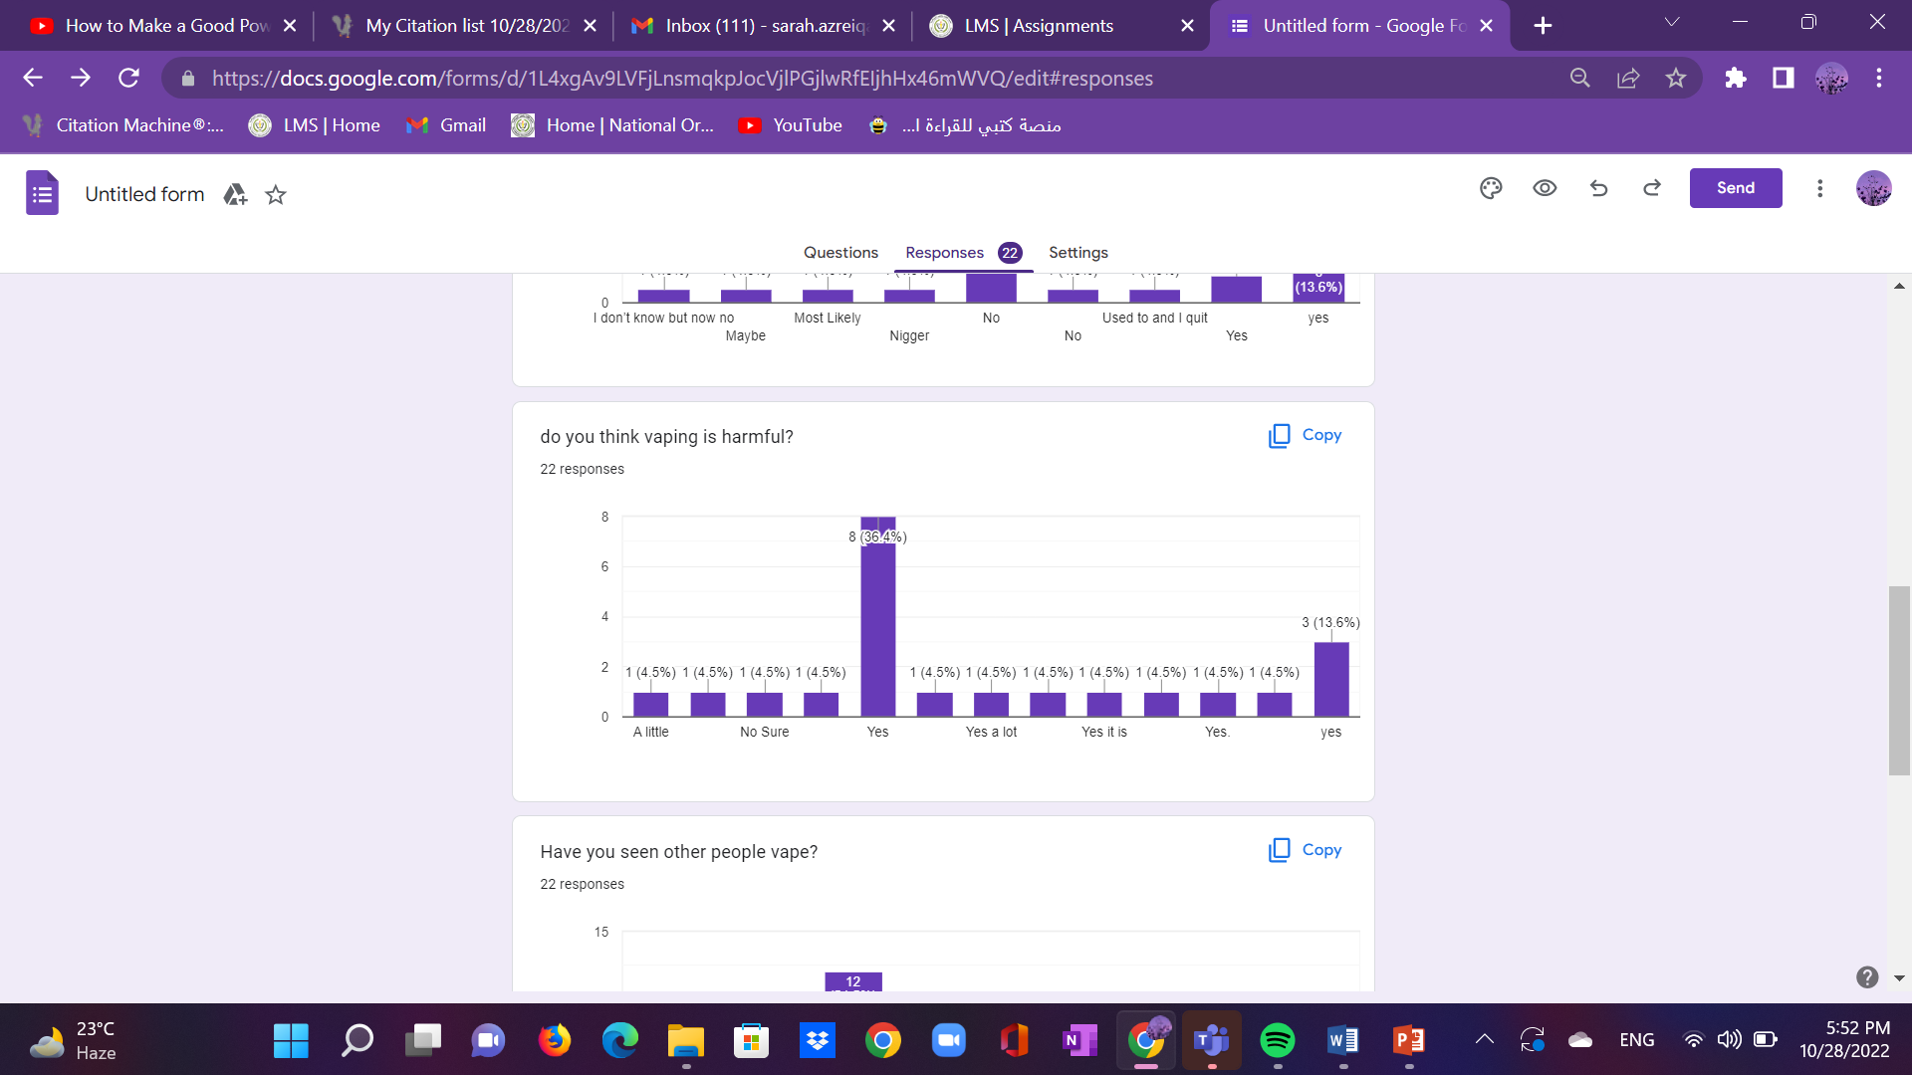

Q 4. Have you seen other people vape?

We got 22 responses

Like the previous question most people answered the same thing which was “yes they have seen other people smoke.”

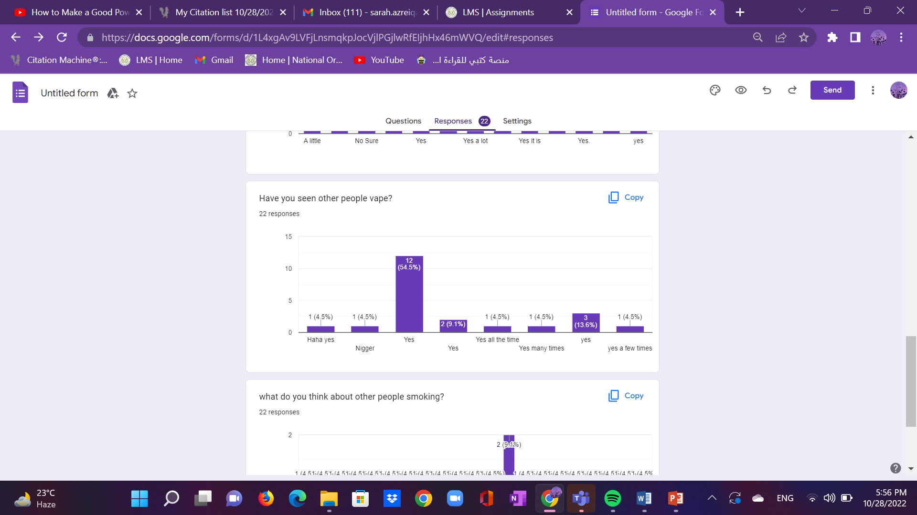

Q5. What do you think about other people smoking?

We got 18 responses

As all the other questions this question was based on opinions but there wasn’t a specific answer to it so we had many different responses regarding this question:

1. They are wrong
2. They are harming themselves
3. Its ok
4. They don’t know their benefit
5. Usually they are stupid
6. I don’t mind it
7. Very bad for their health!
8. Hurting themselves
9. They get addicted to nicotine and they can’t quit which is bad for their health
10. They should quit because it is harmful to their health and might cause serious illnesses
11. Careless
12. I don’t recommend it but at the end of the day people can do what ever they want
13. It is their choice but I don’t think it is reasonable
14. Nothing
15. It is not healthy, it causes addiction which makes you loose money
16. It looks amusing
17. It is a personal choice an addiction that should be discouraged especially with the youth of today
18. Personal issue

