**Diabetes information campaign**

**Global Project**

**Teacher : Yasmine Qaddoumi**

**By: Mariana, Yasmine, Carla, Haya**

**Step 1**

**Find A Clear Focus**

**Research question**

What are the signs/ symptoms of diabetes and how can we prevent it?

**How will we present my information?**

Poster in School.

**How to attract attention?**

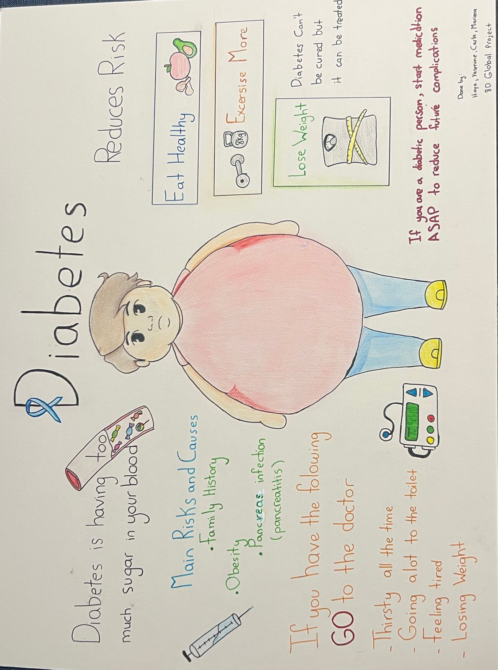We are going to use catchy drawings and phrases in the poster to explain and enhance awareness.

**Step 2**

**Methodology**

An interview with a specialized doctor to talk about diabetes.

Below is the interview:

**Diabetes global project**

**interview**

(answered by a professional Internist Neurologist doctor Dr. Ziad Haddadin )

**What is diabetes?**

There are two types of diabetes type one which affects children while type two affects older age and it is a disease that causes elevated blood sugar because the pancreas is either not excreting enough insulin or the insulin is not working in the body.

**What are the main symptoms of diabetes?**

Diabetes symptoms consist of extreme thirst, increased amount of urine, loss of weight and feeling tired.

Hyperglycaemia, is a common effect of uncontrolled diabetes and over time leads to serious damage to many of the body's systems, especially the nerves and blood vessels.

**What are the main risk factors and causes?**

Family history, obesity, pancreatitis, environment problems.

**How to reduce the risk of diabetes?**

You can reduce the risk by changing your life style, like eating healthy food more often and reducing weight by exercise regularly.

**What is the difference between taking the medicine at an early age and a later age after being diagnosed with diabetes?**

You will reduce the complications of diabetes since you will be able to control your blood pressure, your vascular complications and eye and kidney complications.

**Step 3**

**Cross checking data**

We cross checked the data provided by the doctor in the interview with some reliable medical sites and sources, and all the data were correct.

<https://www.diabetes.org.uk/>

<https://www.mayoclinic.org/diseases-conditions/diabetes/>

<https://www.cdc.gov/diabetes/basics/>

**Step 4**

**Terminology**

Using terms to simplify or describe the doctors’ interview to explain scientific terms which some people do not understand and to select simple phrases to be used in the poster.

Like the below example:

* “Hyperglycaemia, is a common effect of uncontrolled diabetes and over time leads to serious damage to many of the body's systems, especially the nerves and blood vessels.”

“Raised blood sugar causes many diseases and damages many organs such as the heart, the kidneys, and the eyes.”

* Pancreatitis  is pancreas infection

**Step 5**

**Reflection**

How will our campaign help people?

1. Increase awareness on diabetes.
2. Checking up in case they have the symptoms.
3. Help people reduce the risk factors for diabetes.
4. Encourage a healthier life style.

**Step 6**

**Adding our references**

Interview with Dr. Ziad Haddadin.

We used reliable cites for our campaign to cross check the data.

<https://www.diabetes.org.uk/preventing-type-2-diabetes>

<https://www.diabetes.org.uk/diabetes-the-basics/types-of-diabetes/type-2>

<https://www.mayoclinic.org/diseases-conditions/diabetes/symptoms-causes/syc-20371444>

<https://www.cdc.gov/diabetes/basics/risk-factors.html>