1.

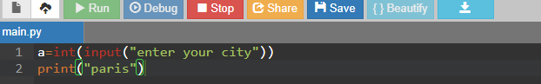

2.

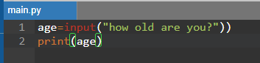

3.

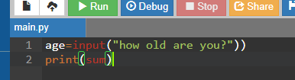

4.Because it is ok to make mistakes , even good programmers make mistakes , but make sure to read the error and in the future you know how to fix or never redo that mistake , then your programs will look the way u want . ☺

Done by: Markella Bursheh.