Test page 69

1. oak

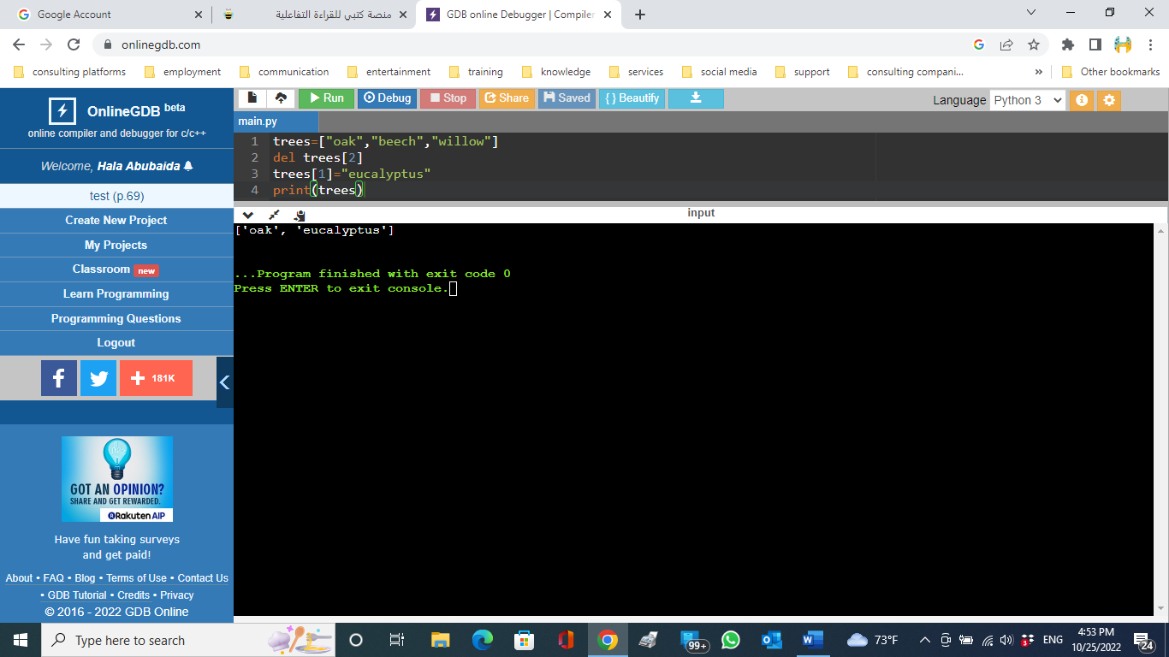2+3.

4. The index number is not within the range.