**Research question:**

**how does the concentration of sucrose affect the rate of fermentation measured by the change of mass in grams?**

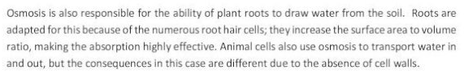**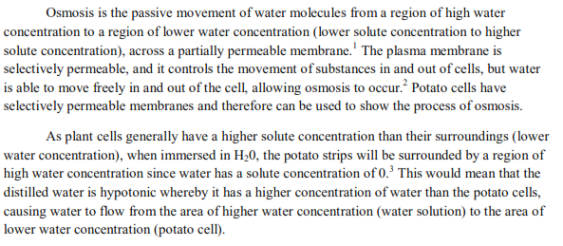Background information:**

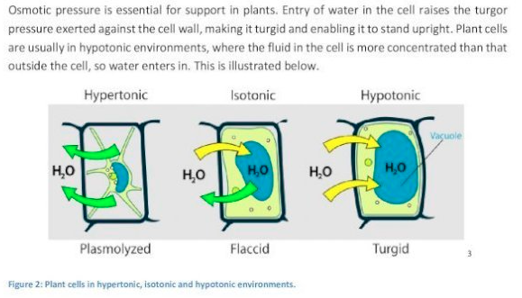

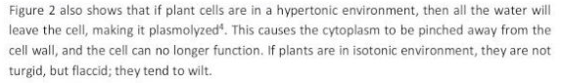

In this lab report , we will preparing different concentrations of sucrose solution and we will measure the water uptake or loss by measuring the change in the masses of potatoes using a digital balance after soaking potato cylinders for fixed period of time .

**Hypothesis:**

**as the concentration of sucrose in the solution increases, the rate of reaction increases.**

**Variables :**

**The independent variable :**

Changing the concentration of 100 cm3 sucrose solution The following concentrations will be prepared as shown in the table below:

Table 1: shows the volumes of water and masses of sucrose that will be used to prepare the different concentrations of sucrose solutions

|  |  |  |
| --- | --- | --- |
| **Mass of Sucrose g ( )** | **Volume of water cm3 ( )** | **Concentration of sucrose solution (%)** |
| **0g** | **15cm3** | **0%** |
| **2.5g** | **15cm3** | **2.5%** |
| **5g** | **15cm3** | **5%** |
| **7.5 g** | **15cm3** | **7.5%** |
| **10g** | **15cm3** | **10%** |
| **12.5g** | **15cm3** | **12.5%** |

The masses of sucrose will be measured using a digital balance (……….)

* And the volume of water will be measured using a 100 cm3 measuring cylinder (…….)
* The uncertainty of the digital balance and the pipette was measured by dividing the smallest increment by 2

**Dependent variable :**

**the concentration of sucrose solution.**

**Controlled Variable:**

|  |  |  |
| --- | --- | --- |
| **Controlled Variable** | **How will you keep this controlled? Stating the values and the equipment that you will be using** | **How could it affect your results if not controlled?** |
| **Temperature** | **Using a thermometer** | **The amount of energy that being consumed in the reaction will be affected** |
| **Amount of water** | **Using a measuring cylinder** | **The time for the reaction to finish will be affected** |
| **Size of potato** | **Using a ruler to measure its length and width** | **It wouldn’t be a fair test** |
| **Mass of potato** | **Using a weighting scale** | **It will affect the final mass if all the potato’s were not the same mass** |

Table 2: description of the controlled variables

**Materials:**

Fill in the materials needed for the experiment

INCLUDE THE – Quantity, volume and UNCERTAINTY

1. **Get a potato and cut it into small 6 pieces**
2. **Bring 100cm3 of sucrose solution**
3. **Get a digital balance**
4. **Set a water bath at 35oc**
5. **Get a thermometer**
6. **Get a 6-potato cylinder**
7. **Cork borer with a diameter of 0.6**
8. **Labeled beaker at 2.5%**
9. **Leave potatoes soaked for 2 hours monitored using a digital clock**
10. **Let the potato’s dry using a blotting paper**

**Procedure:**

Procedure:

1. Clear the working area and place a large white tile.

2. Take out at least 10 potatoes that look most similar to each other. The color and the

approximate size should help in deciding that.

3. Use a 0.6 cm diameter borer to form the potato chips. Try to use as few potatoes as possible

to produce 30 potato chips.

4. To ensure that the chips are of same diameter throughout, insert the borer quickly in a

potato while keeping it straight so that one end of the borer comes out of the other side.

Put the chips on the white tile.

5. Now that all the 30 chips are on the white tile, use a scalpel to peel off any remaining skin

on the potatoes. Do this process one by one until all the chips are clean.

Caution: Scalpels are very sharp; use them carefully.

6. Separate the longer chips from the shorter ones. Using a 15 cm ruler, check if any of the long

ones are longer than 6 cm to be evenly cut in half. This will save time.

7. Use the scalpel to cut all the chips to be accurately 3 cm long using the same ruler each time.

8. Once all the chips are 3 cm long, weigh their mass one by one by using a balance.

9. Make sure they are all within 0.1 g difference of each other.

10. Record this data in the “Initial Mass” section of the table.

11. Take out the tray containing beakers of pre-prepared sucrose solutions- concentrations 0.0

mol dm

-3

(distilled water), 0.2 mol dm

-3

, 0.4 mol dm

-3

, 0.6 mol dm

-3

, 0.8 mol dm

-3

and 1.00

mol dm

-3

.

12. To ensure that the volume of the solutions is 200 cm

3

, use a measuring cylinder. This has to

be repeated twice because the measuring cylinder is 100 cm

3

(hence double the

uncertainty). The lower meniscus should touch the 100 cm

3

mark.

13. With the help of someone else, ensure that you immerse 5 potato chips in each of the

beakers and start the stopwatch at the same time. The 5 potato chips represent trials of

each concentration.

14. Once the stopwatch is running, name the tray containing all the beakers. The experiment

can be left unmonitored in the lab for 4 hours.

15. When the time nears 4 hours, difference in the size of potato chips is noticeable, however

to have quantitative evidence, potato chips must be weighed.

16. After exactly 4 hours, remove the potato chips from the solutions using a spatula carefully,

ensuring none of the potato chips break or get squashed.

17. Try to blot all 30 potato chips using a paper towel equally and weigh them once again.

18. Record the mass of each in the “Final Mass” section of the table.

19. All the lab work is completed for this experiment. Clear the area and clean the apparatus if

required.

Procedure:

1. Clear the working area and place a large white tile.

2. Take out at least 10 potatoes that look most similar to each other. The color and the

approximate size should help in deciding that.

3. Use a 0.6 cm diameter borer to form the potato chips. Try to use as few potatoes as possible

to produce 30 potato chips.

4. To ensure that the chips are of same diameter throughout, insert the borer quickly in a

potato while keeping it straight so that one end of the borer comes out of the other side.

Put the chips on the white tile.

5. Now that all the 30 chips are on the white tile, use a scalpel to peel off any remaining skin

on the potatoes. Do this process one by one until all the chips are clean.

Caution: Scalpels are very sharp; use them carefully.

6. Separate the longer chips from the shorter ones. Using a 15 cm ruler, check if any of the long

ones are longer than 6 cm to be evenly cut in half. This will save time.

7. Use the scalpel to cut all the chips to be accurately 3 cm long using the same ruler each time.

8. Once all the chips are 3 cm long, weigh their mass one by one by using a balance.

9. Make sure they are all within 0.1 g difference of each other.

10. Record this data in the “Initial Mass” section of the table.

11. Take out the tray containing beakers of pre-prepared sucrose solutions- concentrations 0.0

mol dm

-3

(distilled water), 0.2 mol dm

-3

, 0.4 mol dm

-3

, 0.6 mol dm

-3

, 0.8 mol dm

-3

and 1.00

mol dm

-3

.

12. To ensure that the volume of the solutions is 200 cm

3

, use a measuring cylinder. This has to

be repeated twice because the measuring cylinder is 100 cm

3

(hence double the

uncertainty). The lower meniscus should touch the 100 cm

3

mark.

13. With the help of someone else, ensure that you immerse 5 potato chips in each of the

beakers and start the stopwatch at the same time. The 5 potato chips represent trials of

each concentration.

14. Once the stopwatch is running, name the tray containing all the beakers. The experiment

can be left unmonitored in the lab for 4 hours.

15. When the time nears 4 hours, difference in the size of potato chips is noticeable, however

to have quantitative evidence, potato chips must be weighed.

16. After exactly 4 hours, remove the potato chips from the solutions using a spatula carefully,

ensuring none of the potato chips break or get squashed.

17. Try to blot all 30 potato chips using a paper towel equally and weigh them once again.

18. Record the mass of each in the “Final Mass” section of the table.

19. All the lab work is completed for this experiment. Clear the area and clean the apparatus if

required.

1. Prepare 100 cm3 of sucrose solutions using the information shown in table 1
2. Add each solution into a beaker that is labelled with the corresponding concentration
3. Place all solutions in a thermostatically controlled water bath set at 35oC
4. Using a cork borer with a diameter of 0.6 cut out 6 potato cylinders
5. Using a digital balance (…….) measure the initial masses of each potato cylinder and record these values into a table and label them as initial masses
6. add one cylinder of potato into the beaker labelled 2.5 %
7. repeat step 6 using the other concentrations of sucrose
8. leave all the potatoes soaked for 2 hours monitored using a digital clock
9. after 2 hours remove all the potato cylinder and dry them gently using blotting paper
10. measure the final masses of each potato cylinder and record these values in a table and label them as final masses

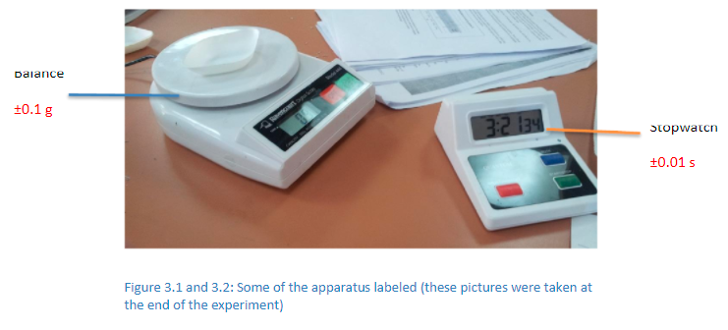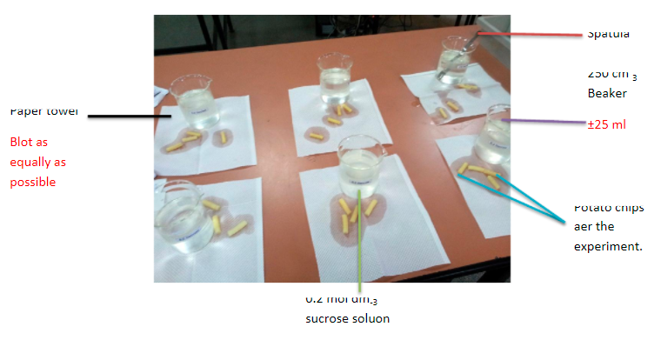

**Safety, ethical and environmental considerations:**

Safety : be careful while using scissors to avoid possible cuts in the skin

Ethical : No human or animals subjects are used during the experiment

Environmental : no harmful chemicals that will harm the environment are used , care was taken when selecting the volumes and masses used so as not to overconsume the chemicals

The sucrose solutions were safely disposed into the sink after completing the experiment

**Construct a table to write your qualitative and quantitative data .**

**Qualitative :**

|  |  |
| --- | --- |
| **Concentration of sucrose solution %** | **Observation** |
| **2.5%** | **Mass will increase from 2.32 g to 2.64** |
| **5%** | **Mass will increase from 2.32 g to 2.39** |
| **7.5%** | **Mass will increase from 2.33 g to 2** |
| **10%** | **Mass will increase from 2.32 g to 2.21** |
| **12.5%** | **Mass will increase from 2.32 g to 2.10** |
| **0%** | **Mass will increase from 2.32 g to 2.18** |

Table ( …..,) …………………………………………………………………..

**Raw data :**

**Quantitative :**

|  |  |  |
| --- | --- | --- |
| **Concentration of sucrose solution %** | **Initial mass g (± 0.01)** | **Final mass g (± 0.01)** |
| **0%** | **2.32** | **2.18** |
| **2.5%** | **2.32** | **2.64** |
| **5%** | **2.32** | **2.39** |
| **7.5%** | **2.33** | **2** |
| **10%** | **2.32** | **2.21** |
| **12.5** | **2.32** | **2.10** |

Table (…….) ………………………………………….

**Processed data :**

|  |  |  |
| --- | --- | --- |
| **Concentration of sucrose solution %** | **Change in mass g** | **Percentage change %** |
| **0%** | **-0.14** | **-12.43** |
| **2.5%** | **0.32** | **12.54** |
| **5%** | **0.07** | **8.03** |
| **7.5%** | **-0.33** | **0.23%** |
| **10%** | **-0.11** | **-1.42%** |
| **12.5%** | **-0.22** | **-12.59%** |

Table (……..) ………………………………………