***Elon Reeve Musk***

Elon Reeve Musk FRS is a business magnate and investor. He is the founder, CEO, and chief engineer of SpaceX; angel investor, CEO, and product architect of Tesla, Inc.; founder of The Boring Company; and co-founder of Neuralink and OpenAI.

Born: June 28, 1971 (age 51 years)

Children: [Vivian Jenna Wilson](https://www.google.com/search?q=Vivian+Jenna+Wilson&stick=H4sIAAAAAAAAAOPgE-LUz9U3MM6rSjNU4gIx8yxTjPPStKSyk630C1LzC3JSgVRRcX6eVXJGZk5KUWreIlbhsMyyzMQ8Ba_UvLxEhfDMHKD0DlbGXexMHIwA_NDT7VMAAAA&sa=X&ved=2ahUKEwiLjuGbkNb6AhWR_7sIHUsXDSgQmxMoAHoECCcQAg),

Net worth: 219.8 billion USD (2022) [Forbes](http://www.forbes.com/billionaires/)

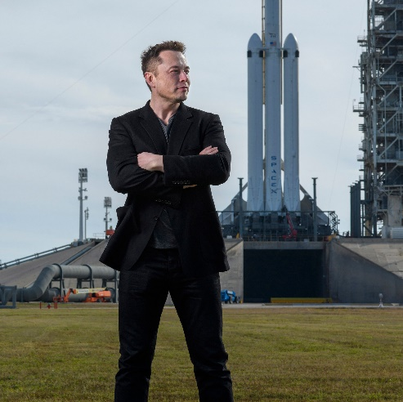Spouse: [Talulah Riley](https://www.google.com/search?sa=X&bih=657&biw=1360&hl=en&q=Talulah+Riley&stick=H4sIAAAAAAAAAOPgE-LUz9U3MM6rSjNUAjOTKoqzK7QkspOt9AtS8wtyUoFUUXF-nlVxQX5pceoiVt6QxJzSnMQMhaDMnNTKHayMu9iZOBgBxZ29n0oAAAA&ved=2ahUKEwj8i4j_kdb6AhWKgv0HHdt1Bv0QmxMoAHoECCIQAg) (m. 2013–2016), [Talulah Riley](https://www.google.com/search?sa=X&bih=657&biw=1360&hl=en&q=Talulah+Riley&stick=H4sIAAAAAAAAAOPgE-LUz9U3MM6rSjNUAjOTKoqzK7QkspOt9AtS8wtyUoFUUXF-nlVxQX5pceoiVt6QxJzSnMQMhaDMnNTKHayMu9iZOBgBxZ29n0oAAAA&ved=2ahUKEwj8i4j_kdb6AhWKgv0HHdt1Bv0QmxMoAXoECCIQAw) (m. 2010–2012), [Justine Musk](https://www.google.com/search?sa=X&bih=657&biw=1360&hl=en&q=Justine+Musk&stick=H4sIAAAAAAAAAOPgE-LUz9U3MM6rSjNU4gIxjcwKcivNtSSyk630C1LzC3JSgVRRcX6eVXFBfmlx6iJWHq_S4pLMvFQF39Li7B2sjLvYmTgYASt-Yr5KAAAA&ved=2ahUKEwj8i4j_kdb6AhWKgv0HHdt1Bv0QmxMoAnoECCIQBA) (m. 2000–2008)

Education: [University of Pennsylvania](https://www.google.com/search?sa=X&bih=657&biw=1360&hl=en&q=University+of+Pennsylvania&stick=H4sIAAAAAAAAAOPgE-LUz9U3MM6rSjNU4gAxzUtSirWks5Ot9AtS8wtyUoFUUXF-nlVqSmlyYklmft4iVqnQvMwyoGhmSaVCfppCQGpeXnFlTlliXmbiDlbGXexMHAwAYBuXXlkAAAA&ved=2ahUKEwj8i4j_kdb6AhWKgv0HHdt1Bv0QmxMoAHoECCUQAg) (1992–1997), MORE

Parents: [Errol Musk](https://www.google.com/search?sa=X&bih=657&biw=1360&hl=en&q=Errol+Musk&stick=H4sIAAAAAAAAAOPgE-LUz9U3MM6rSjNU4gIxC9OzjIpNtSSzk630C1LzC3JSgVRRcX6eVUFiUWpeSfEiVi7XoqL8HAXf0uLsHayMu9iZOBgBwV-lxUkAAAA&ved=2ahUKEwj8i4j_kdb6AhWKgv0HHdt1Bv0QmxMoAHoECCYQAg), [Maye Musk](https://www.google.com/search?sa=X&bih=657&biw=1360&hl=en&q=Maye+Musk&stick=H4sIAAAAAAAAAOPgE-LUz9U3MM6rSjNU4gIxC9OzjLKTtSSzk630C1LzC3JSgVRRcX6eVUFiUWpeSfEiVk7fxMpUBd_S4uwdrIy72Jk4GAEFLQUsSAAAAA&ved=2ahUKEwj8i4j_kdb6AhWKgv0HHdt1Bv0QmxMoAXoECCYQAw)

Nationality: American, Canadian, South African

Entrepreneur Elon Musk has achieved global fame as the chief executive (CEO) of electric autos maker Tesla Inc. ([TSLA](https://www.investopedia.com/markets/quote?tvwidgetsymbol=tsla)) and CEO of the private space company SpaceX. Musk co-founded PayPal ([PYPL](https://www.investopedia.com/markets/quote?tvwidgetsymbol=pypl)), was [an early investor](https://www.investopedia.com/articles/investing/031316/elon-musks-5-best-investments-tsla-pypl.asp) in several tech companies, and in April 2022 he began negotiations for a deal to take Twitter Inc. ([TWTR](https://www.investopedia.com/markets/quote?tvwidgetsymbol=TWTR)) private.

His success and personal style has given rise to comparisons to other colorful tycoons from U.S. history, including [Steve Jobs](https://www.investopedia.com/articles/fundamental-analysis/12/steve-jobs-apple-story.asp), Howard Hughes, and [Henry Ford](https://www.investopedia.com/articles/markets/123015/ford-vs-chevy-comparing-business-models-and-strategies-f-gm.asp). He was named the [richest person in the world](https://www.investopedia.com/articles/investing/012715/5-richest-people-world.asp) with an estimated net worth of $220 billion as of June 2022.