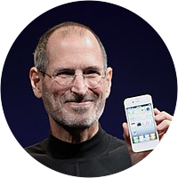 |  | Steve JObs  American Entrepreneur  Who Is STEVE JOBS?  Steven Paul Jobs (February 24, 1955 – October 5, 2011) was an American entrepreneur, industrial designer, business magnate, media proprietor, and investor. He was the co-founder, chairman, and CEO of Apple; the founder, chairman, and CEO of NeXT. He is widely recognized as a pioneer of the personal computer revolution of the 1970s and 1980s, along with his early business partner and fellow Apple co-founder Steve Wozniak.  How DID STEVE JOBS START APPLE ?  In 1975, the 20-year-old Steve Jobs and Steve Wozniak set up shop in Jobs' parents' garage, dubbed the venture Apple, and began working on the prototype of the Apple I. They attended meetings of the Homebrew Computer Club, which helped them develop and market their Apple product.  APPLE’S GROWTH  Apple became a public company in 1980 and share prices skyrocketed. Some staff members suddenly became millionaires and Apple entered the Fortune 500 as one of the fastest-growing companies in history.  WHAT WAS STEVE JOBS PASSION?  Steve Jobs was not passionate about technology. He was passionate about calligraphy, western history, and dance. If he had followed his passions he would have ended up doing something very different. What he did do, was leverage his zone of genius and used his passions as a way to direct it.

