**Elon Musk**, (born June 28, 1971, in South Africa)

He is a South African-born, Canadian/American entrepreneur, business magnate, industrial designer, and engineer. He is the co-founder and chief designer of many innovative companies that changed and transformed our life such as:

* X.com in 1999, which later became PayPal.
* SpaceX in 2002 and Tesla Motors in 2003. The Maker of electrical vehicles and spacecraft.

Elon Mask is one of the richest people in the world, as his work revolves around human progress and idealism.

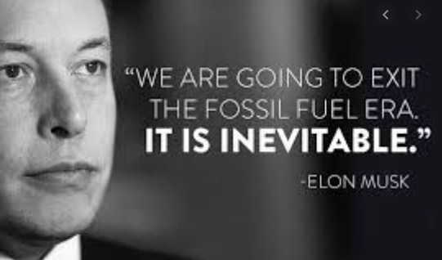

**Early life**

Musk was born to a South African father and a Canadian mother. He showed talent for computers  and entrepreneurship at an early age. At age 12 he created a video game  and sold it to a computer magazine. In 1988, he gained Canadian passport, then left South Africa because he viewed the greater economic opportunities available in the United States.

Although, Musk received bachelor’s degrees in physics and economics in 1997. But his passion towards the Internet had much more potential to change society than work in physics.

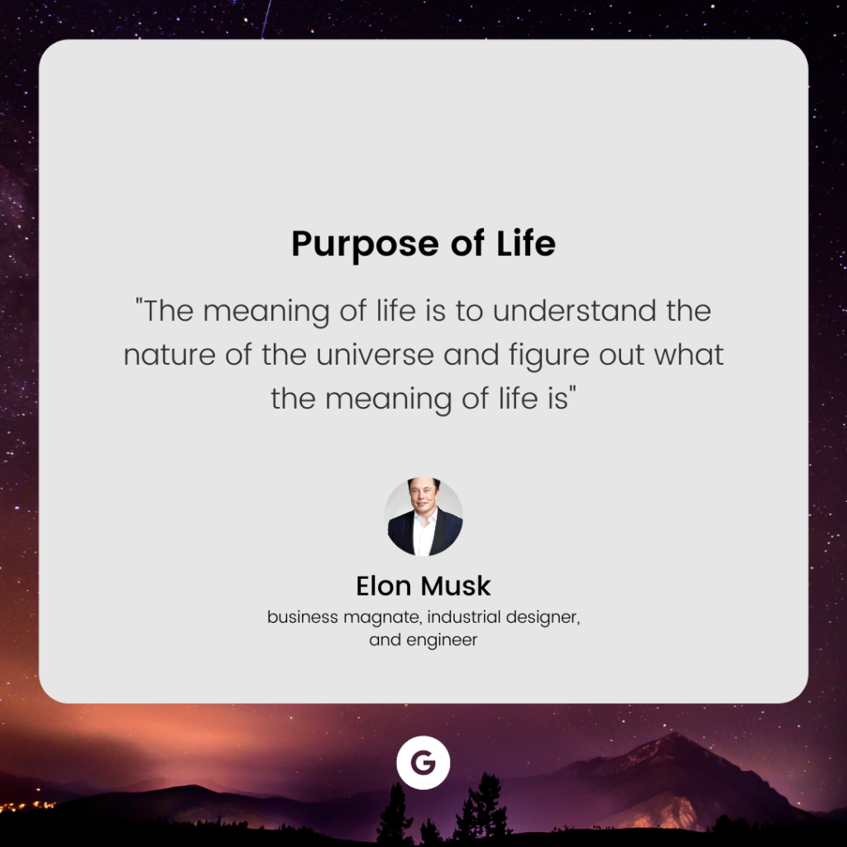

In 1995 he founded Zip2, a company that provided maps and business directories to online.

He made his first million in his late 20s when Compaq Computers purchased his start-up company Zip2. He is a hard worker, and he works as many as 80 to 120 hours per week.

Lately in September 2022, Twitter’s shareholders voted to accept Musk’s offer of taking, the giant social media company, Twitter private but Elon Mask putting deal “on Hold”.

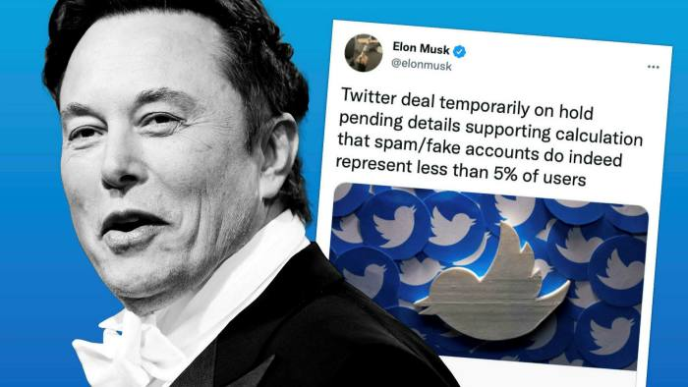

In recent days, Elon Musk has had success in his business and has created a lifestyle everyone would want to emanate.

