Thomas Alva Edison

What was Thomas Edison passionate about?

Edison slept little for he was gripped by a passion for **manipulating electrical currents in new ways**. In 1876, he set up a laboratory in Menlo Park, New Jersey where he could devote his full attention to invention. He promised that he would turn out a minor invention every ten days and a big invention every six months.

How he started a business

In 1859, Edison took a job **selling newspapers and candy on the Grand Trunk Railroad to Detroit**. In the baggage car, he set up a laboratory for his chemistry experiments and a printing press, where he started the Grand Trunk Herald, the first newspaper published on a train.

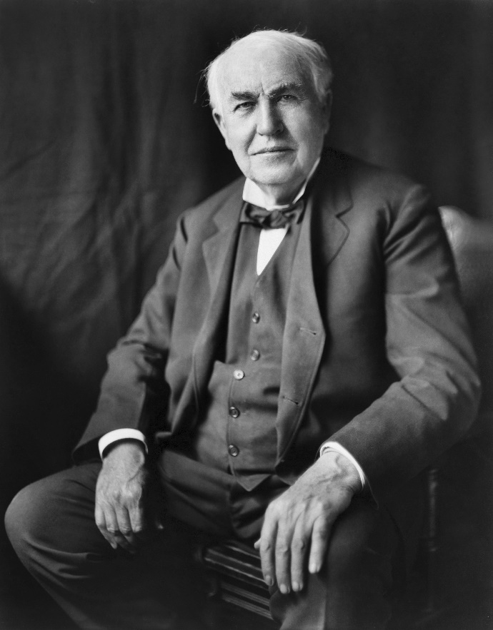**Founded:**Edison Portland Cement Company

**Spouse:**Mina Miller Edison

**Inventions:**Phonograph

**Professions:**Inventor

Nationality

**Thomas Edison is American**