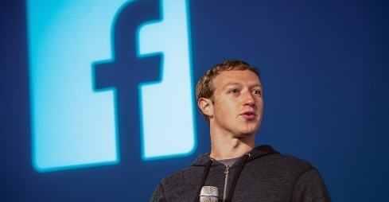

[This Photo](https://www.getrealphilippines.com/2017/12/liberation-liberal-party-facebooks-mark-zuckerberg-named-philippine-hero/) by Unknown Author is licensed under [CC BY-SA](https://creativecommons.org/licenses/by-sa/3.0/)

**Mark Zuckerberg**

On May 14, 1984, Mark Zuckerberg was born in White Plains, New York. As a child, he showed an affinity for computers. He learned the BASIC programming language at a nearby college, and at the age of 12, he developed an instant-messaging application that his father used in his office. Together with his friends, he also created computer games just for fun.

Zuckerberg attended Harvard University but dropped out after his sophomore year to focus on developing Facebook. The site grew out of two earlier ventures: FaceMash, a website for ranking the attractiveness of other Harvard students, and HarvardConnection.com, an online social networking platform.

Zuckerberg and his friends Dustin Moskovitz, Chris Hughes and Eduardo Saverin created The Facebook, a site that allowed users to create their own profiles, upload photos, and communicate with other users. The group ran the site out of a dorm room at Harvard University until June 2004.

**Facebook Accomplishments**

In mid-2005, Facebook raised $12.7 million in [venture capital](https://www.investopedia.com/terms/v/venturecapital.asp) and expanded access to hundreds of universities and high schools. One year later, the social network opened to the general public, and Yahoo! offered $1 billion to buy the company—a bid that was swiftly rejected by Zuckerberg. Instead, he focused on expanding the site, opening up his project to outside developers and adding more features.

In 2012, Facebook went [public](https://www.investopedia.com/terms/p/publiccompany.asp) and became the most successful Internet [initial public offering](https://www.investopedia.com/terms/i/ipo.asp) (IPO) in history when it raised $16 billion. That same year, Facebook bought the photo-sharing application Instagram.

Meta has acquired dozens of companies over the years, including Instagram for $1 billion in 2012, WhatsApp for $22 billion in cash and shares in 2014, Oculus VR for $2 billion in 2014, and several other companies ranging from [artificial intelligence](https://www.investopedia.com/terms/a/artificial-intelligence-ai.asp) (AI) to identification platforms.