**The National Orthodox School /Shmaisani**

**Subject: Chemistry**

**Name: ayoub Topic: States of matter**

**Date: 10/5/2022 Grade-Section: 6CS- all sections**

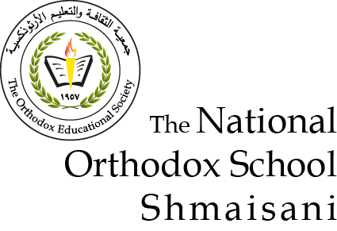

Starters

* Use the particle model to describe solid, liquids and gases and to explain the properties of solids and liquids.
* *Draw particle diagrams of solids and gases to model the arrangement of particles in the different states of matter.*
* Make a table and write the difference between boiling and evaporation.

|  |  |  |  |  |
| --- | --- | --- | --- | --- |
|  | **What temperature it takes place in** | **Where does it take place** | **Is it fast or slow** |  |
| **evaporation** | **At any temperature** | **It takes place at the top of the substace** | **slow** |  |
| **boiling** | **At the the boiling point** | **Bubbles everywhere in the substace** | **fast** |  |

Dessert

**CHOOSE ONE DISH**

* Draw the process of water cycle.

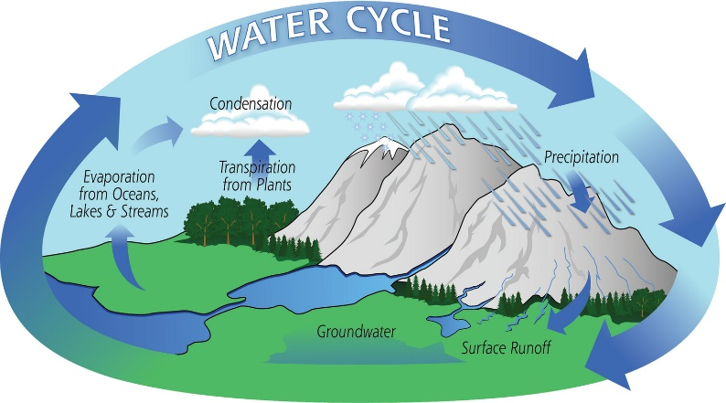

[This Photo](https://theconversation.com/rising-co2-levels-are-changing-how-fast-forests-cycle-water-40746) by Unknown Author is licensed under [CC BY-ND](https://creativecommons.org/licenses/by-nd/3.0/)

* Draw a diagram that shows the changes in states and write the names of the processes on the arrows. (be creative)