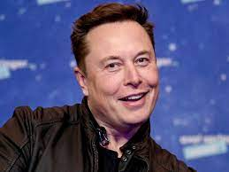**Elon Musk**

He is a global entrepreneur fame as the chief executive (CEO) of electric autos maker Tesla Inc. and CEO of the private space company SpaceX.

Musk has also co-founded PayPal and was an early investor in several tech companies, and in April 2022 he began negotiations for a deal to take over Twitter.

**His passion:** He loves what he's doing because he does what he loves.

Elon is passionate about both SpaceX and Tesla equally. He has put in all his money, all his efforts into both the companies so He is a perfect case study for someone whose work ethic is fueled by his passion.

**How did he start:** After graduating, he briefly enrolled for a physics PhD at Stanford University, California before setting up online business directory Zip2 with his younger brother Kimbal in 1995. The pair sold the firm in 1999 for $307 million, with Elon Musk himself receiving $22 million from the deal.

**Born:**June 28, 1971 (age 51 years)

**Nationality**: South African, American and Canadian

**Net** **Worth**: 254.6 billion USD